500083 Lab Book

# Week 1 – Lab A

Date: 4th Feb 2021

## Q1. Hello World

### Question:

Locate the Solution Explorer within Visual Studio and select the Hello World project. Right click on this project and select Build. This should compile and link the project. Now run the Hello World program.

Change between Debug and Release mode. Compile again and rerun the program.

### Solution:

#include <iostream>

int main(int, char**) {

std::cout << "Hello World" << std::endl;

return 0;

}

### Test data:

n/a

### Sample output:

n/a

### Reflection:

This is programming 101

### Metadata:

Hello World

### Further information:

argv contains any parameters that were passed to the program.

argc holds the number of parameters passed to the program when it was started.

## Q2. Console Window

### Question:

Create a new Empty C++ Console project called Temperature and write a program to input a Fahrenheit measurement, convert it and output a Celsius value.

### Solution:

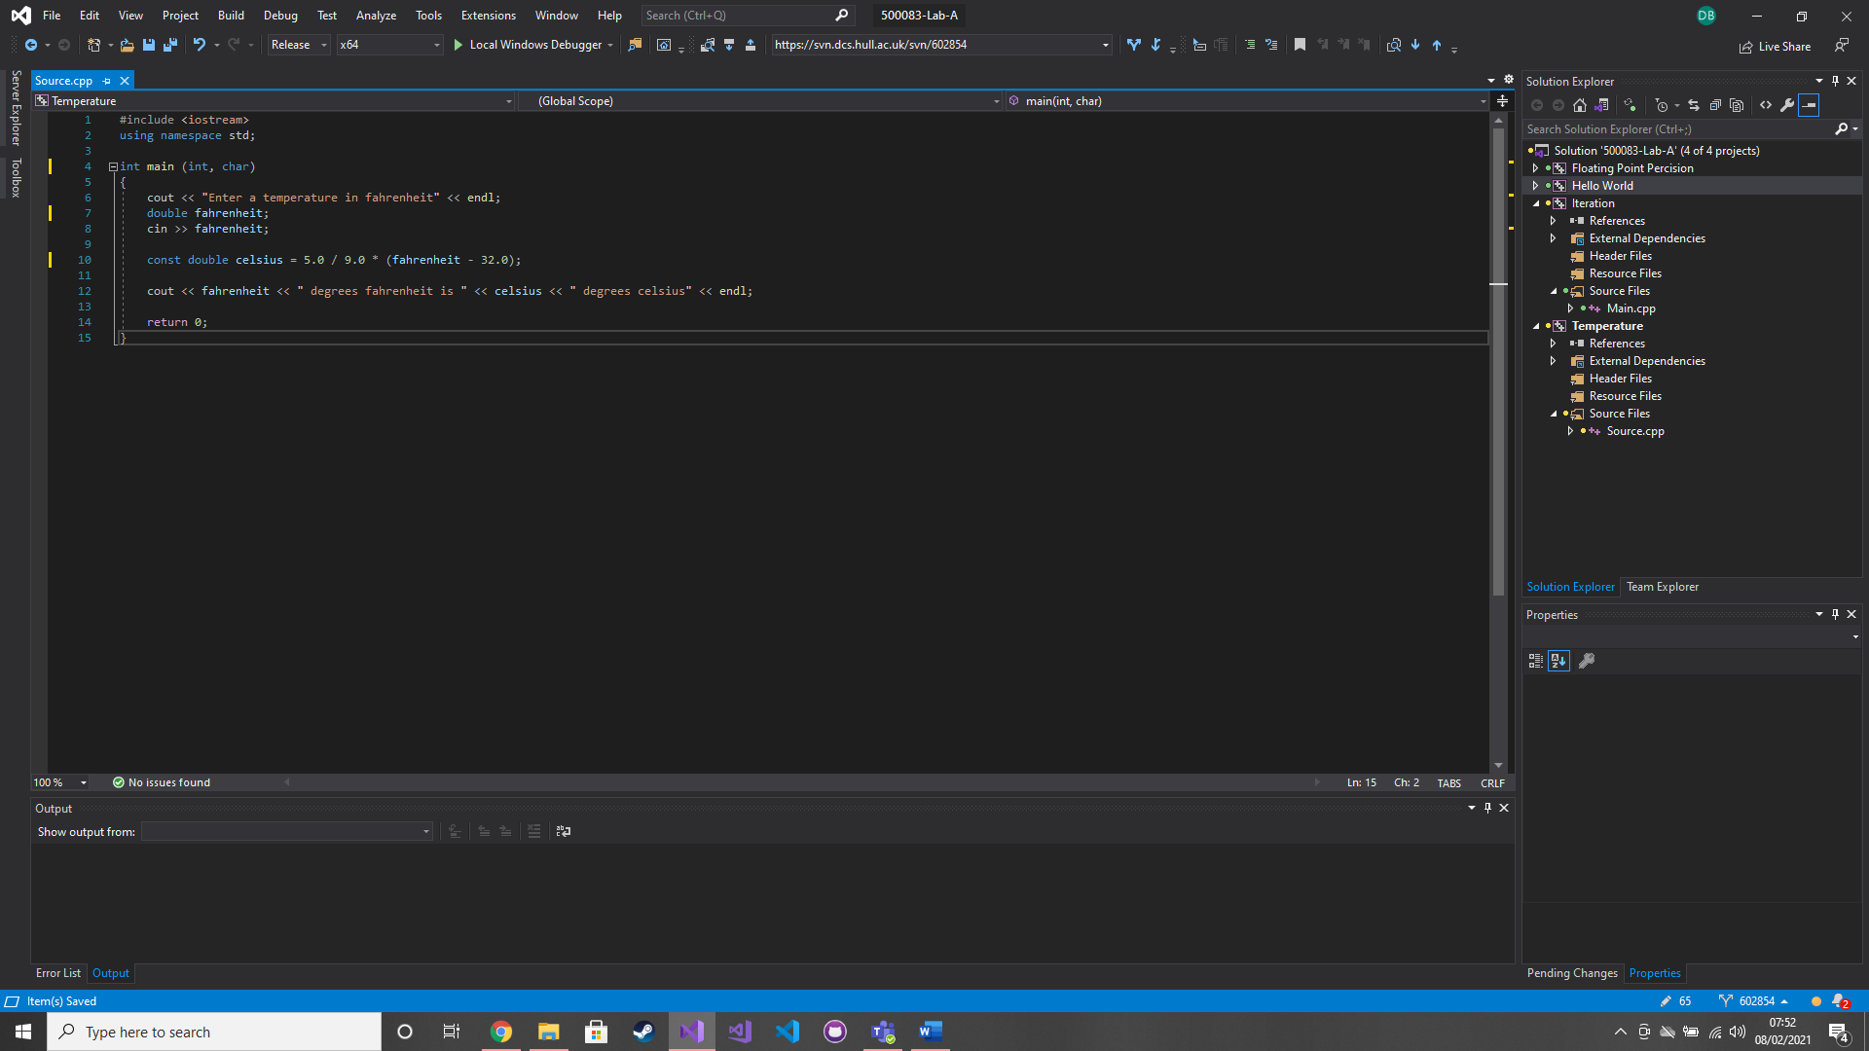

### Test data:

100 degrees F

### Sample output:

37.7778 degrees C

### Reflection:

C++ doesn’t like to divide integers

### Metadata:

Temperature conversion

### Further information:

n/a

## Q3. Types

### Question:

Write a program that prints out the size in bytes of each of the fundamental data types in C++.

### Solution:

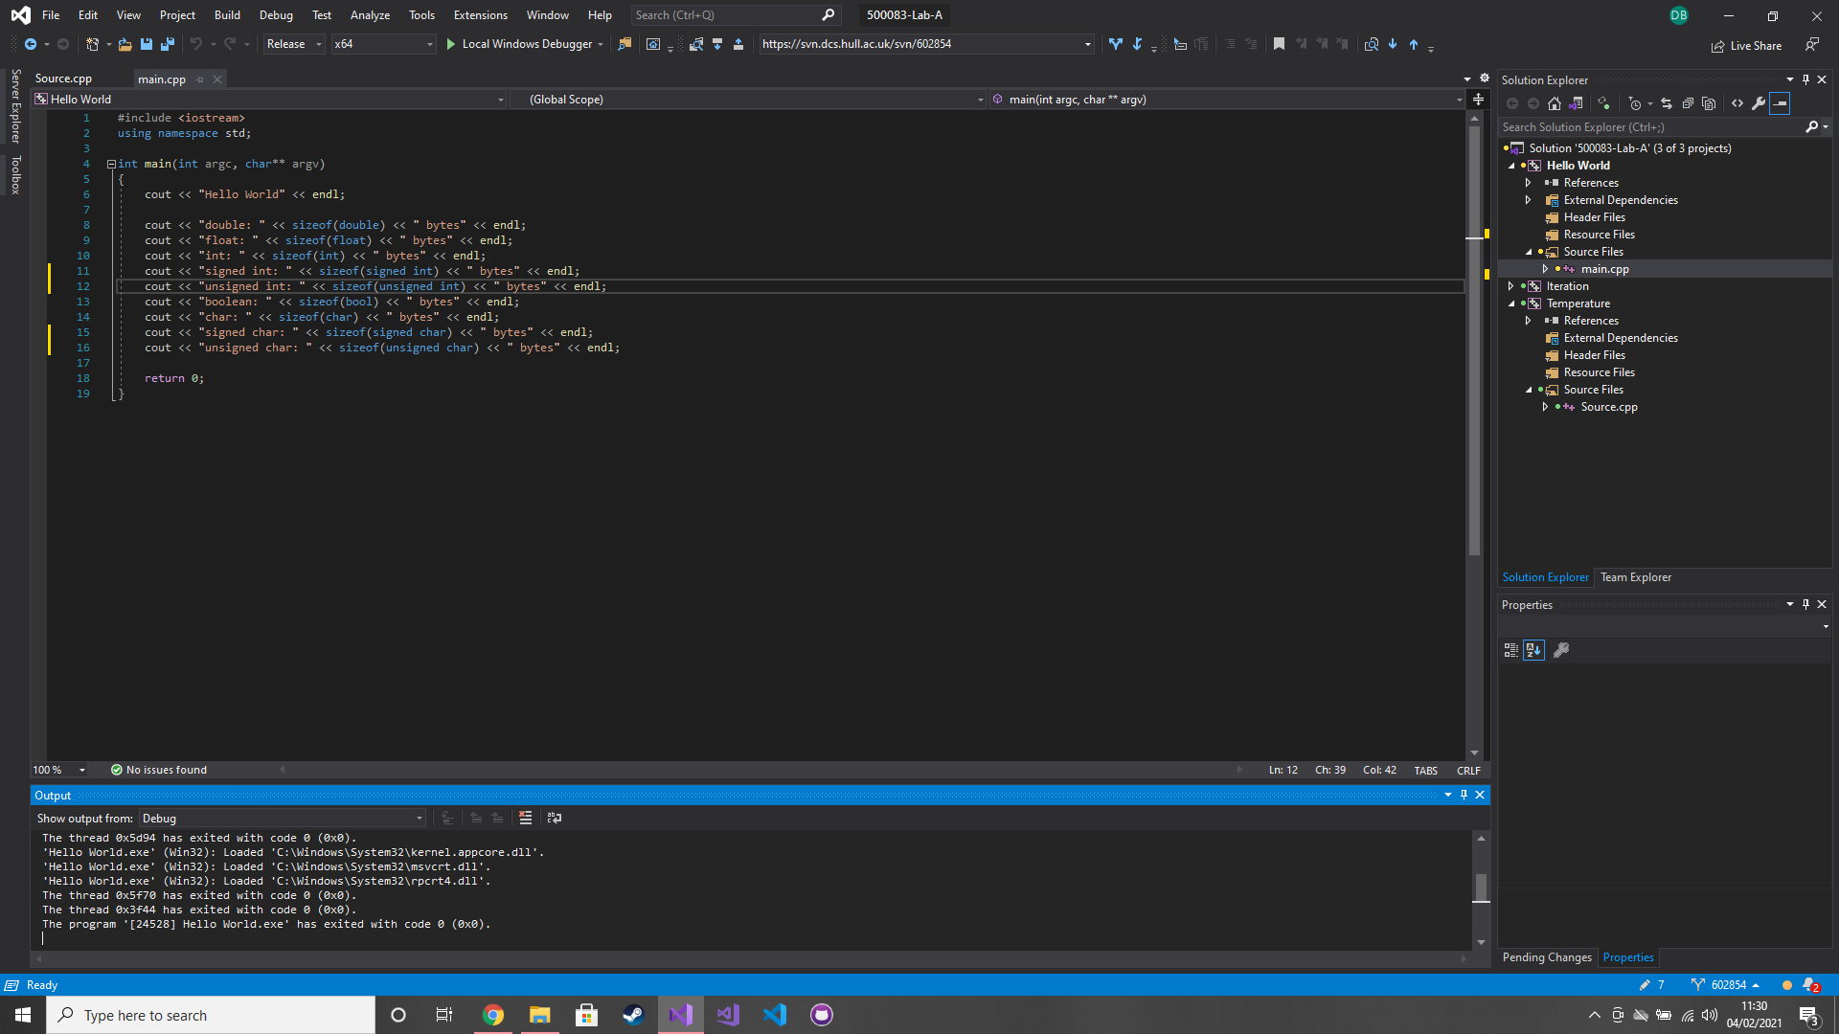

### Test data:

n/a

### Sample output:

double: 8 bytes

float: 4 bytes

int: 4 bytes

signed int: 4 bytes

unsigned int: 4 bytes

boolean: 1 byte

char: 1 byte

signed char: 1 byte

unsigned char: 1 byte

### Reflection:

There is not a difference in byte size of signed and unsigned data types

### Metadata:

Data type sizes

### Further information:

n/a

## Q4. Floating point precision

### Question:

Create a program to test the precision of floating-point numbers

### Solution:

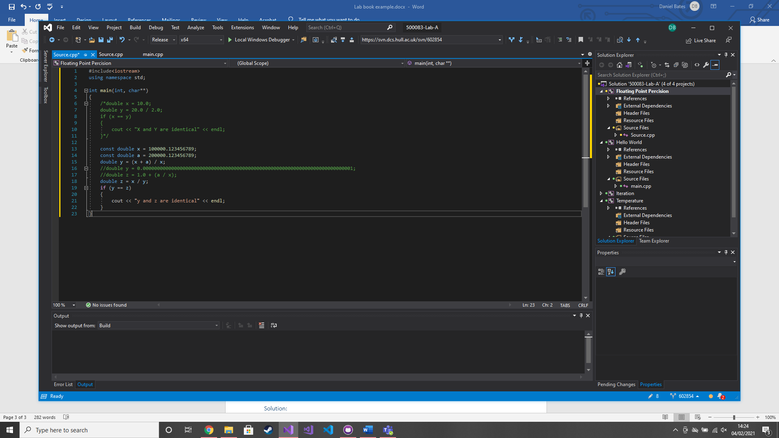

### Test data:

Used lots of different numbers and calculations as test data

### Sample output:

X and Y are identical

Y and z are identical

### Reflection:

You need to have a really small number to have a divide by zero error

It feels like I was supposed to run into more errors than I did

### Metadata:

n/a

### Further information:

Commented out lines are used for other tests or questions

## Q5. C#/C++ Iteration Comparison (for loop)

### Question:

Port the above C# code in to C++ using the provided Main.cpp file

### Solution:

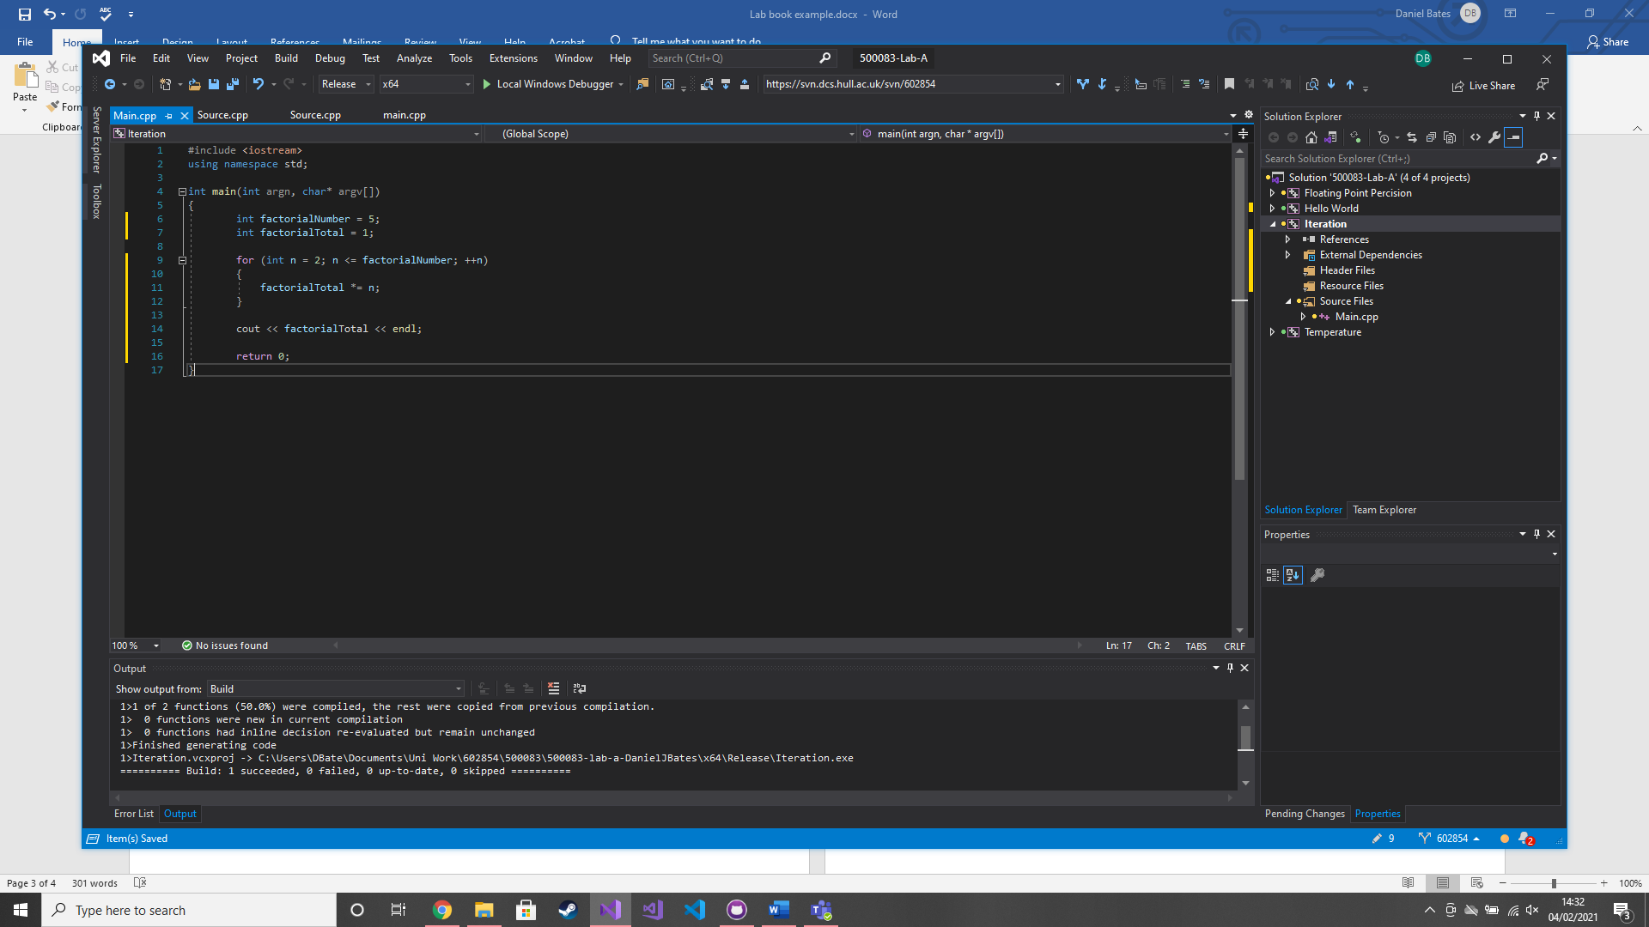

### Test data:

n/a

### Sample output:

120

### Reflection:

Only really had to change how the factorialTotal is displayed onto the console

### Metadata:

n/a

### Further information:

n/a

## Q6. Calculate Average using Iteration (while loop)

### Question:

Using a while loop (or do-while loop), calculate the average value of values provided by the user from the console

### Solution:

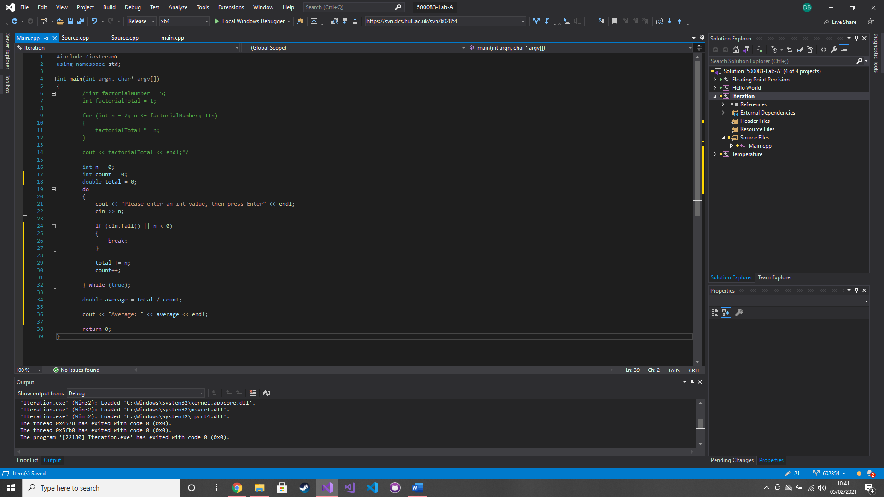

### Test data:

1 1 1 1

5 5

12 3

### Sample output:

1

5

7.5

### Reflection:

If cin can’t assign the input, due to non-matching type or other reasons, I can use cin.fail() to check

### Metadata:

While loop

### Further information:

n/a

# Week 2 – Lab B

Date: 11th Feb 2021

### Q1. The Good >> Streaming Operator

### Question:

Add ‘using namespace std;’, a third variable that is a string type & add code to take a string value from the user after you take the float value then output the string value to the console after you output the float value.

### Solution:

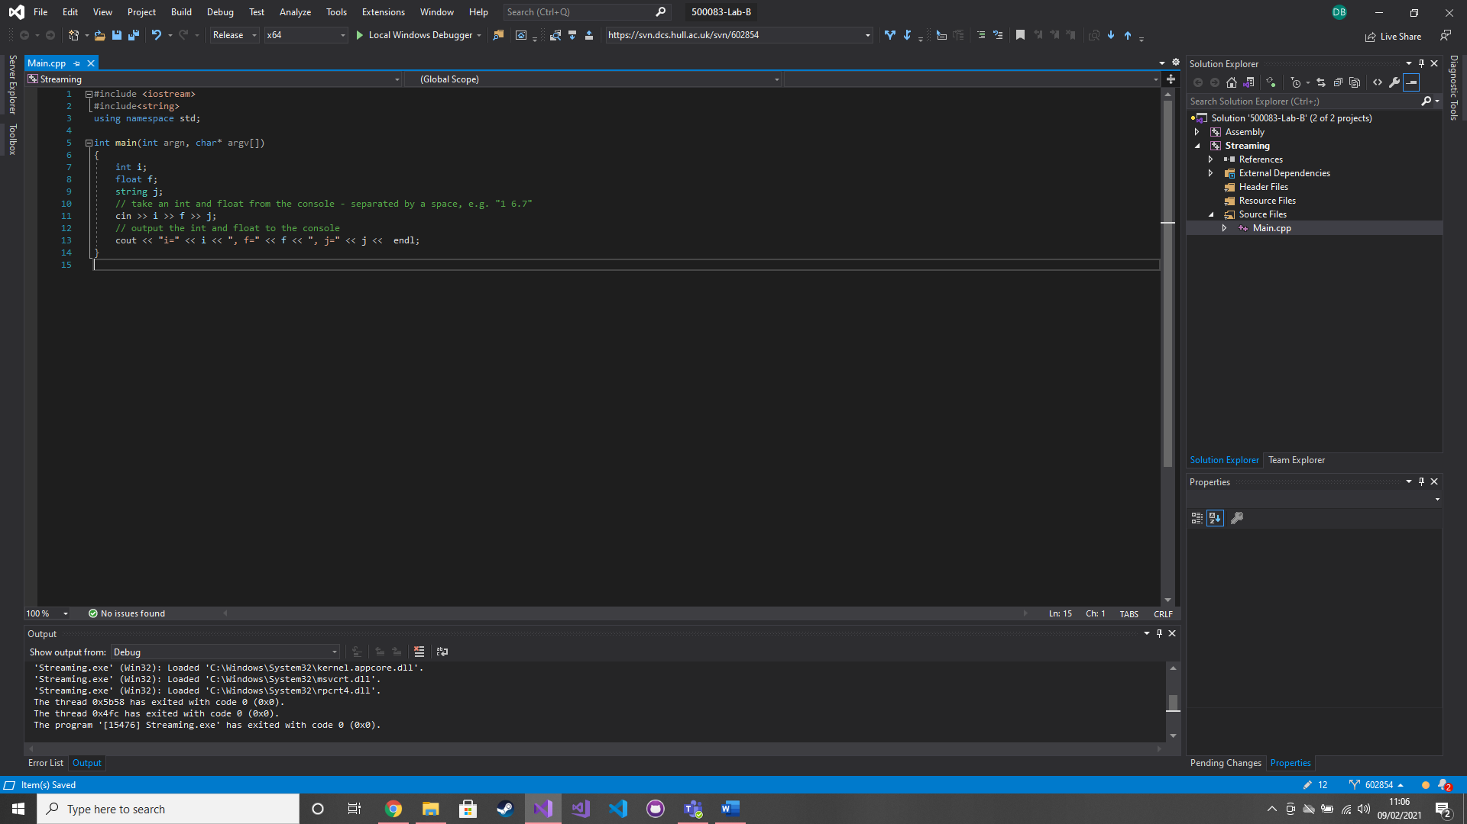

### Test data:

1 1.1 hello

23 4.586 Hello

### Sample output:

i=1, f=1.1, j=hello

i=23, f=4.586, j=Hello

### Reflection:

If I want to use a string in need to include it

Warren mentioned its good practice to use std:: instead of using namespace std

### Metadata:

Standard library & string

### Further information:

n/a

### Q2. The Bad >> Streaming Operator

### Question:

Place a break point on the cout line of the code. Run the above program. In the console, enter the values 123 before selecting the return key. Run the program again, but this time enter the values 123456789 before selecting the return key.

### Solution:

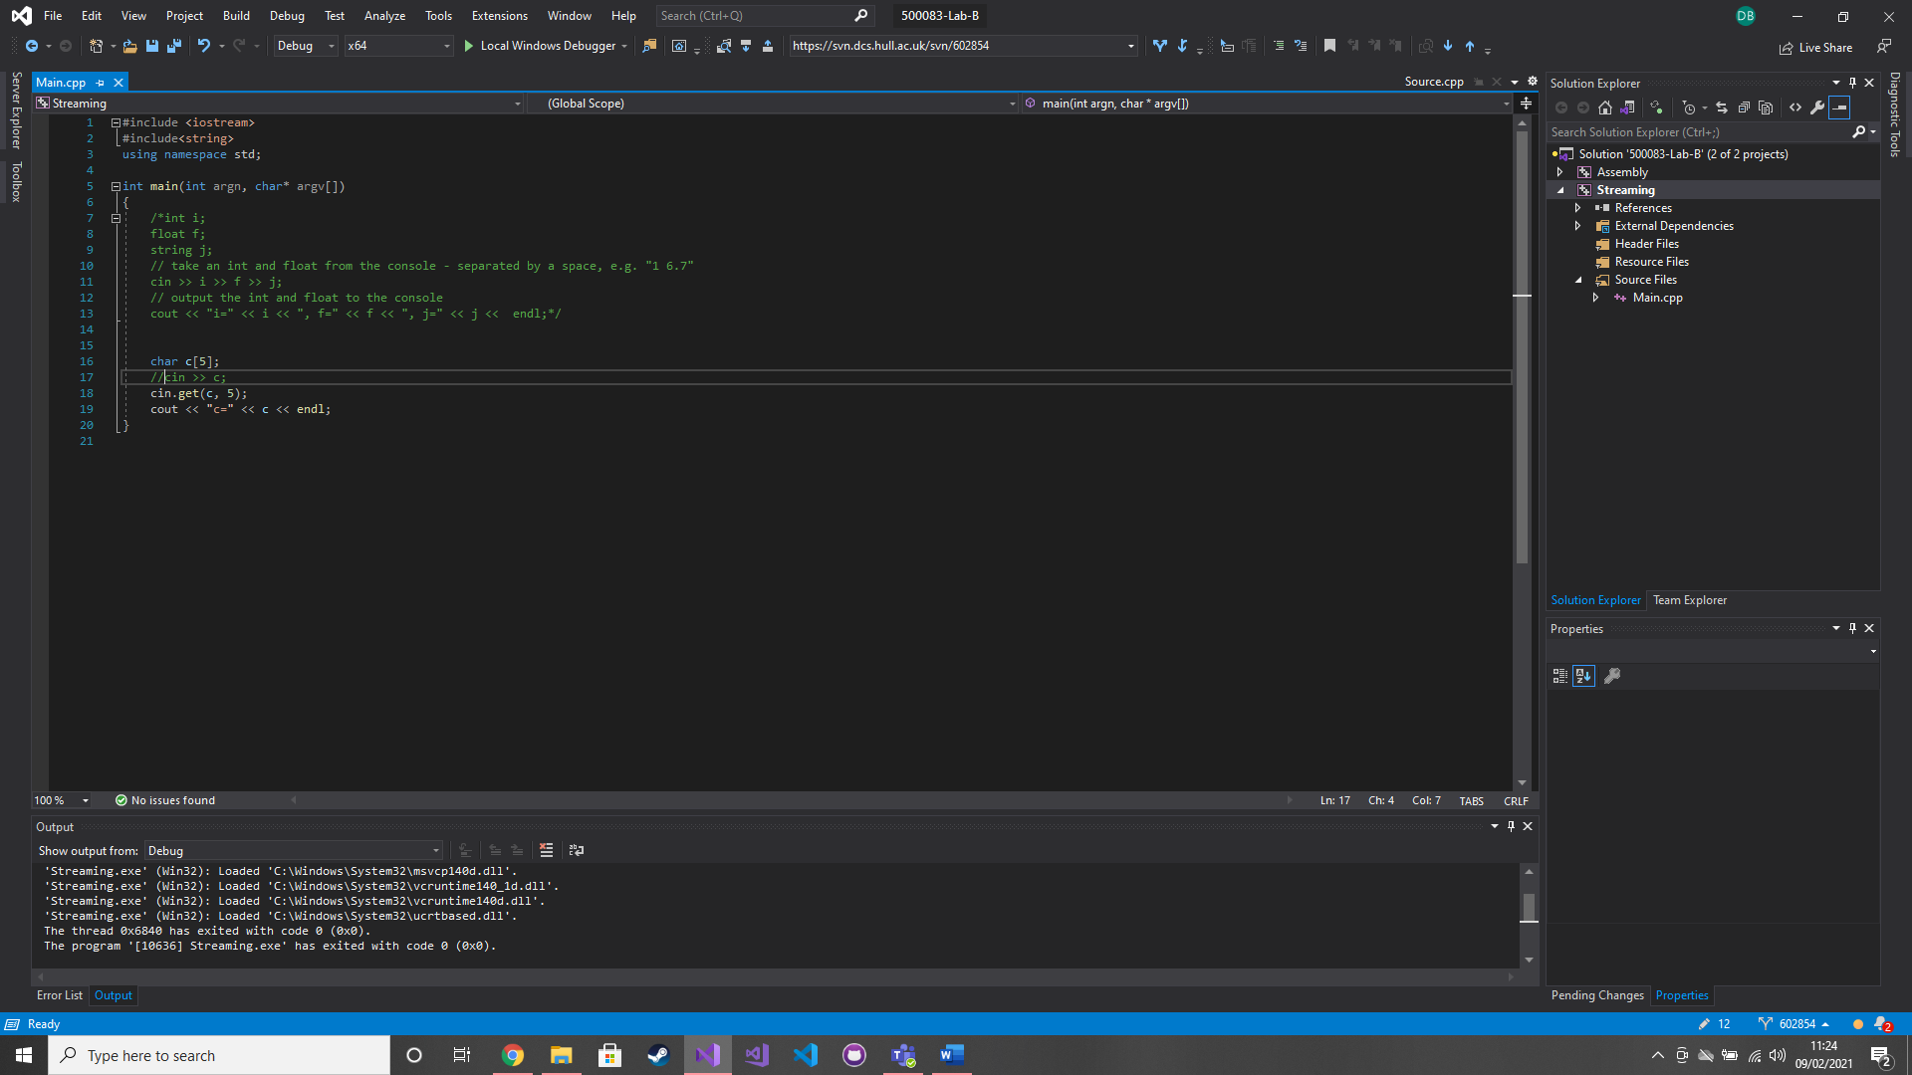

### Test data:

123

123456789

### Sample output:

n/a

### Reflection:

cin.get() is better for storing multiple characters in an array than cin >>

### Metadata:

Storing in arrays

### Further information:

n/a

### Q3. Assembly Language

### Question:

Compile and run the program. Then place a breakpoint on line 5. Use F10 to step through the program and watch the local variables window. Do the same but with F11. Disassemble the program. View the registers and step through the program make notes of the changes. Open the memory window and copy the address of the stack from the stack pointer within the Register window then paste it into the edit field. Make note of the changes. Recompile and run in release mode.

### Solution:

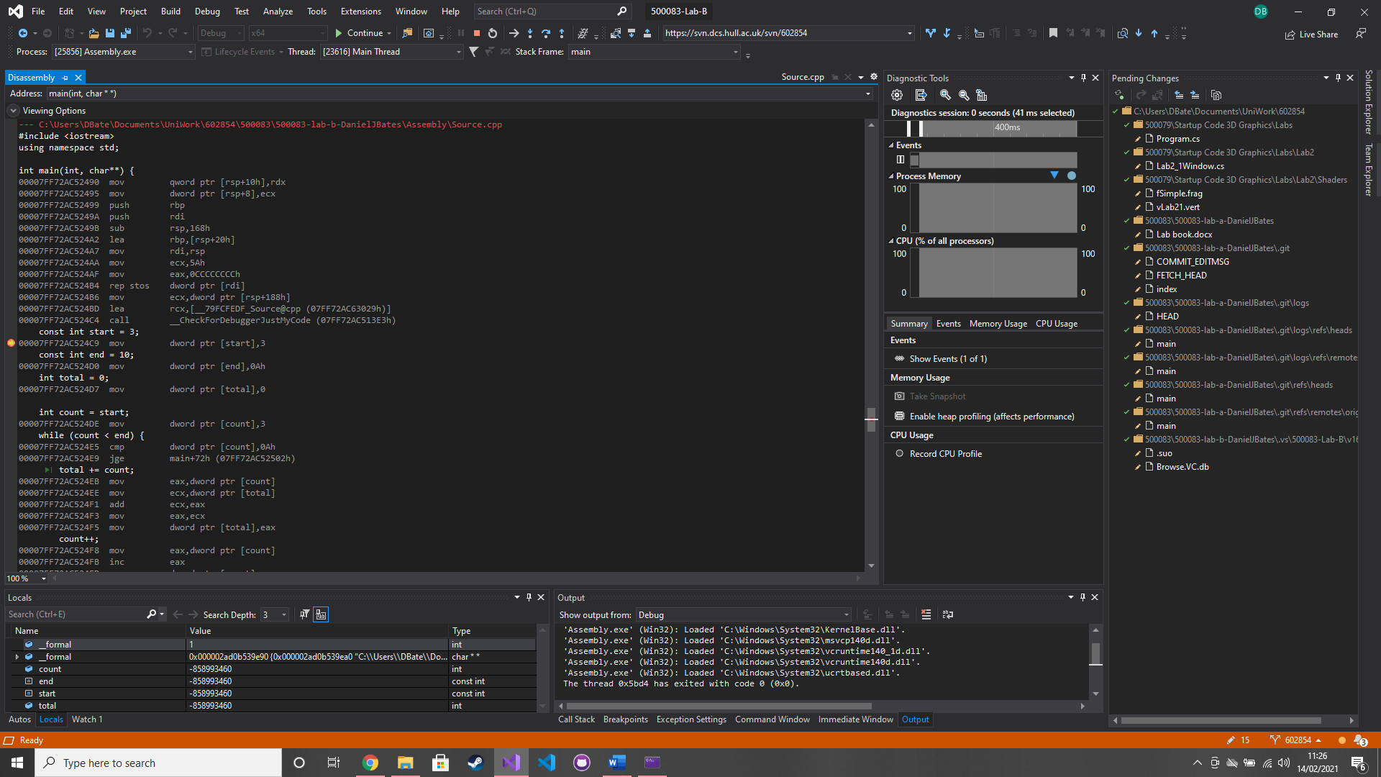

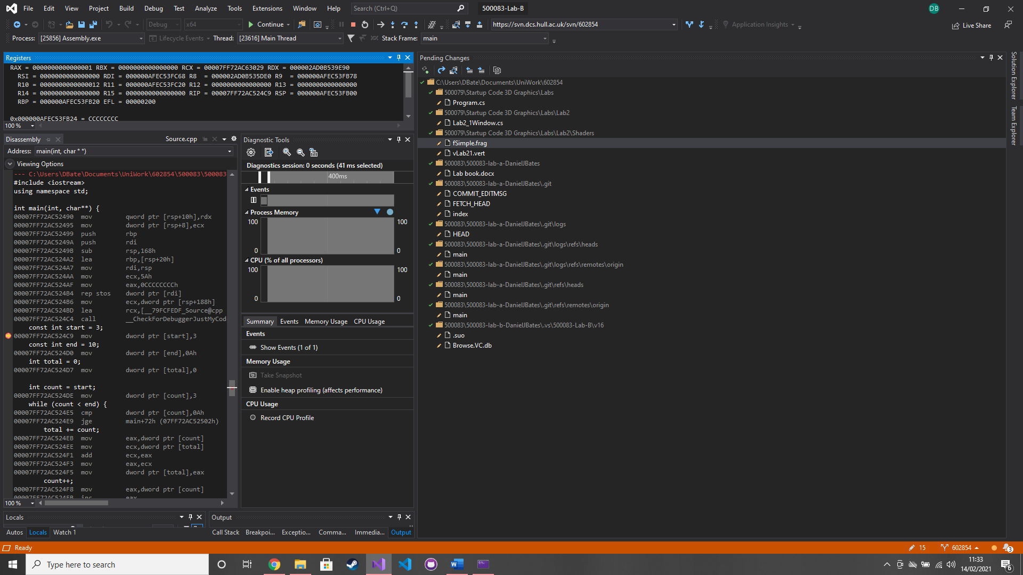

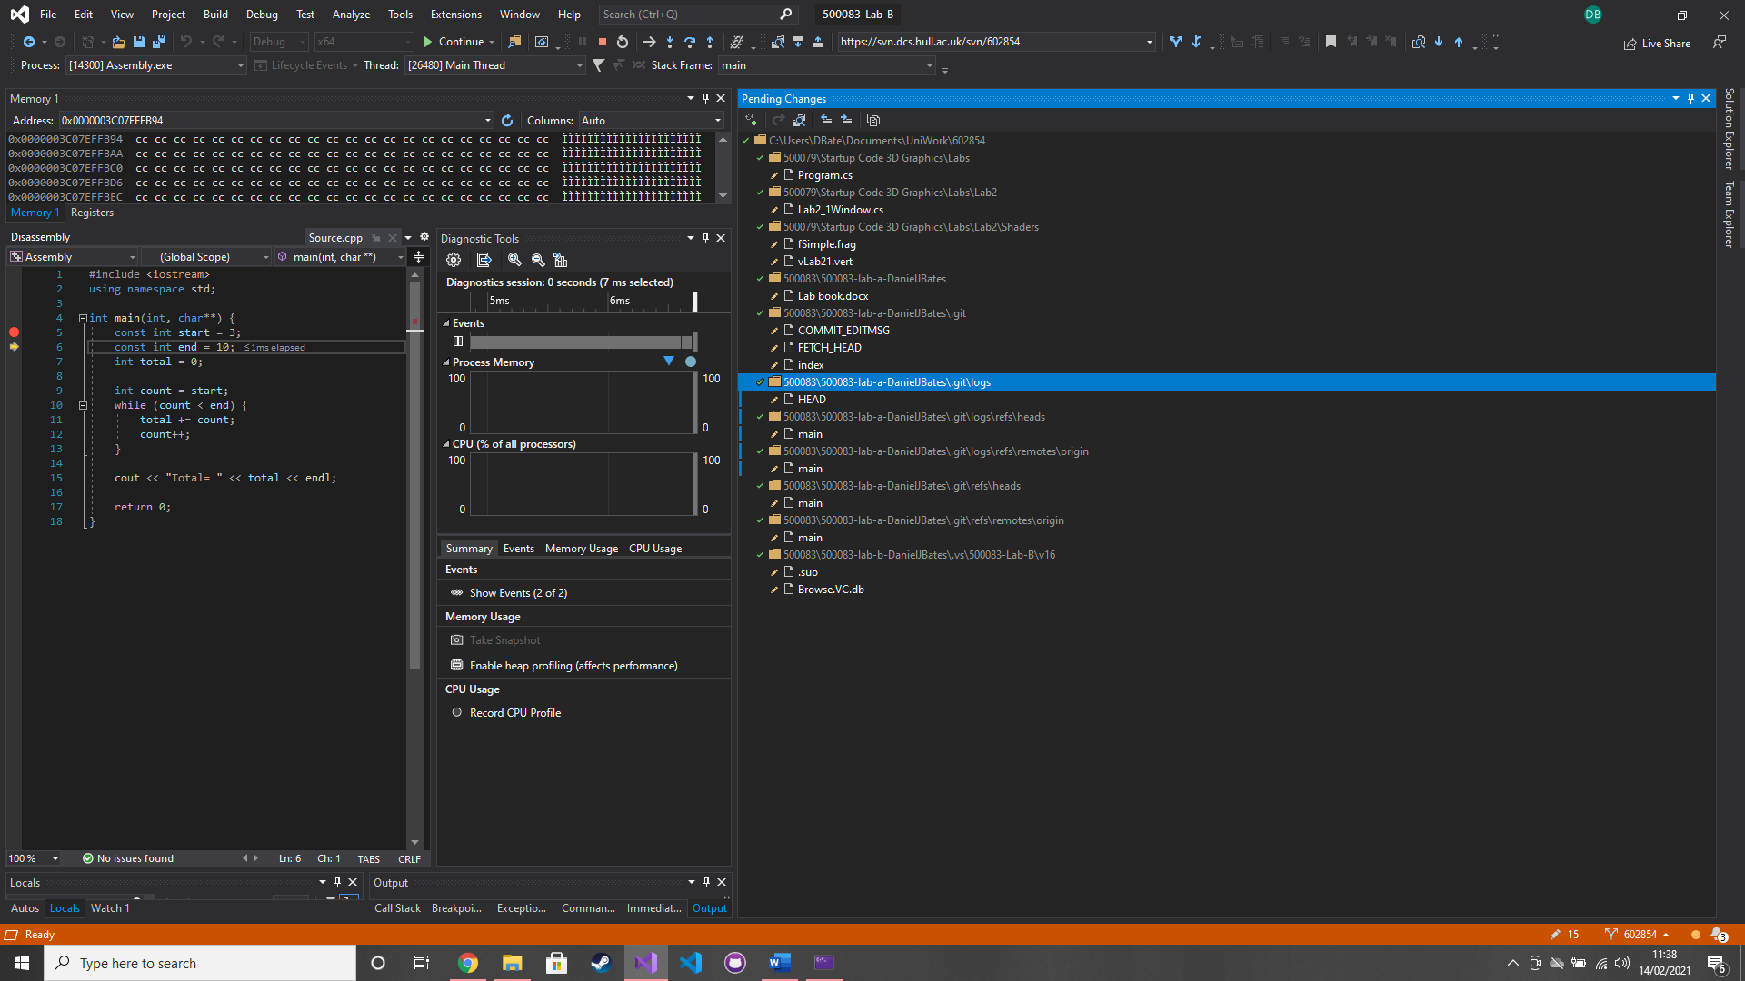

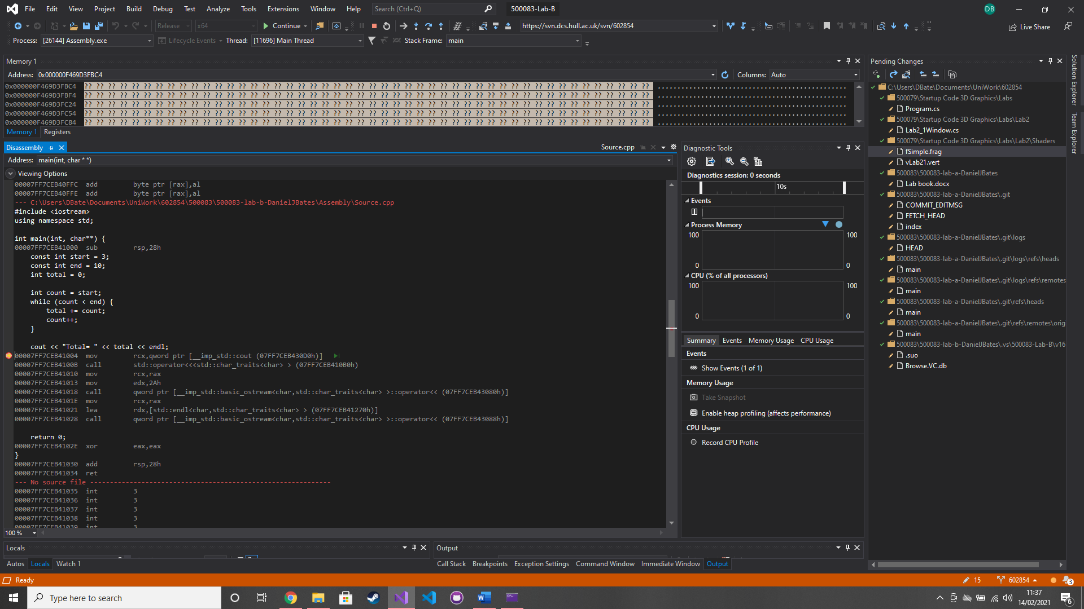

### Test data:

n/a

### Sample output:

n/a

### Reflection:

This is a bit daunting and I don’t really understand this but the code has been optimised.

### Metadata:

Assembly language

### Further information:

I’m disappointed there was not a question called the ugly streaming operator.

# Week 3 – Lab C

Date: 15th Feb 2021

### Q1. Passing Command Arguments

### Question:

Enter input.txt output.txt into the Command Arguments.

### Solution:

Project > Properties > Debugging > Command arguments

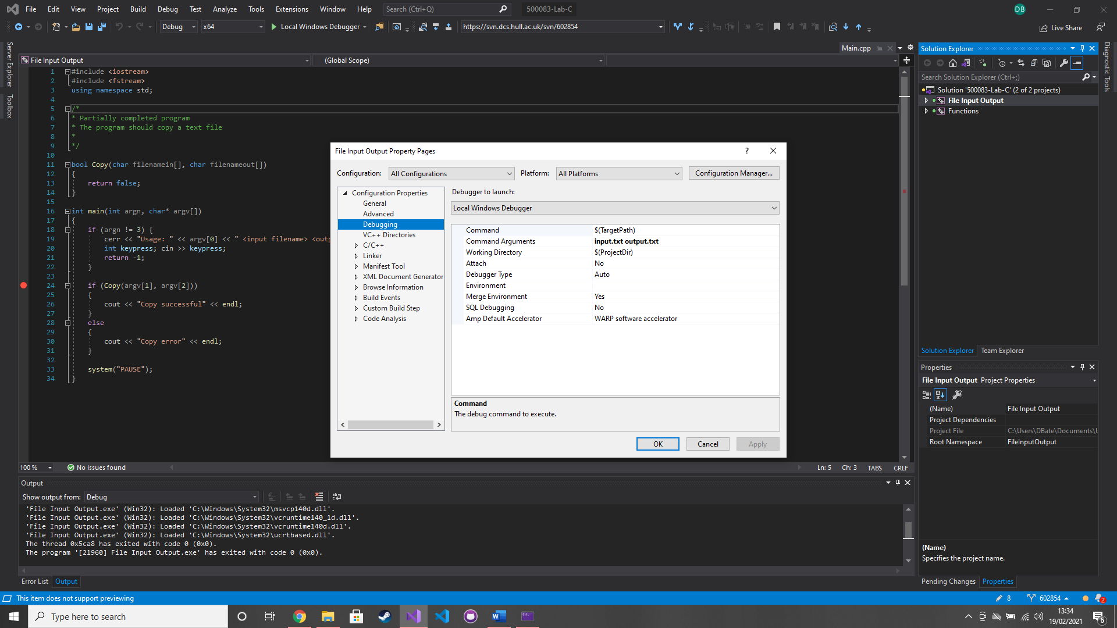

### Test data:

n/a

### Sample output:

n/a

### Reflection:

Argv[1] will now contain input.txt

Argv[2] will now contain output.txt

### Metadata:

Command arguments

### Further information:

n/a

### Q2. Copying a text file

### Question:

Complete the functionality inside of the Copy(char filenamein[], char filenameout[]) function.

### Solution:

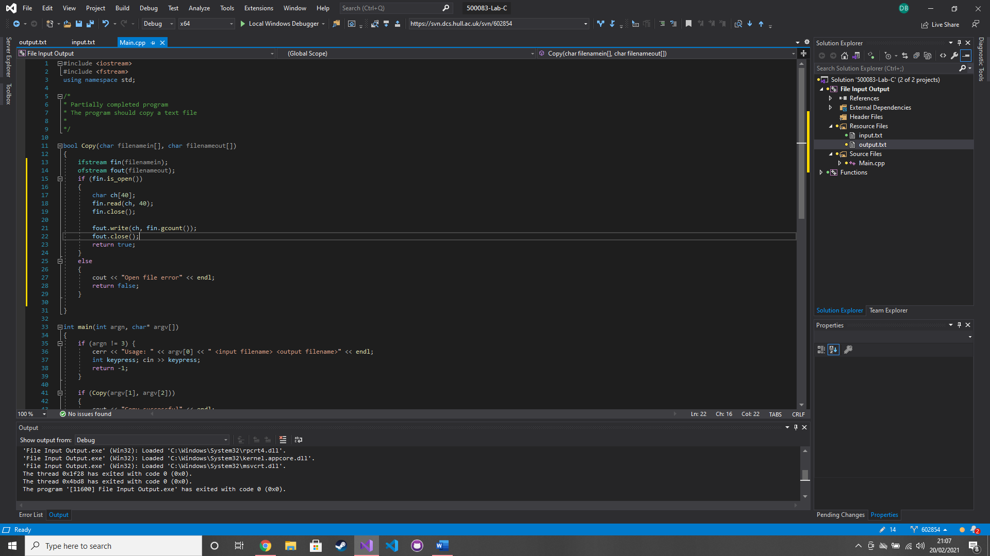

### Test data:

n/a

### Sample output:

Copy Successful

### Reflection:

This is pretty much the same as in c#.

I can use fin.get() and a while loop to work with any size file

### Metadata:

Copy

### Further information:

n/a

### Q3. Function call mechanism

### Question:

Compile and run the program. Place a breakpoint on line 14 and disassemble the code, then open the registers. Step through and execute the following line; **00413204 call mymax (040124Eh).** Take note of the changes to memory location. Continue and execute; **0041322B call std::operator<<<std::char_traits<char> > (0401663h)** and look how the command prompt executes the function. Now execute the line after; **0041320C mov dword ptr [max],eax** make note of the EAX register, copy and paste this into the memory address box and then in the memory window scroll up 4 lines. Execute the next 2 line and make note of the changes. Now modify the code and add in your own function that takes 3 parameters each of a different type.

### Solution:

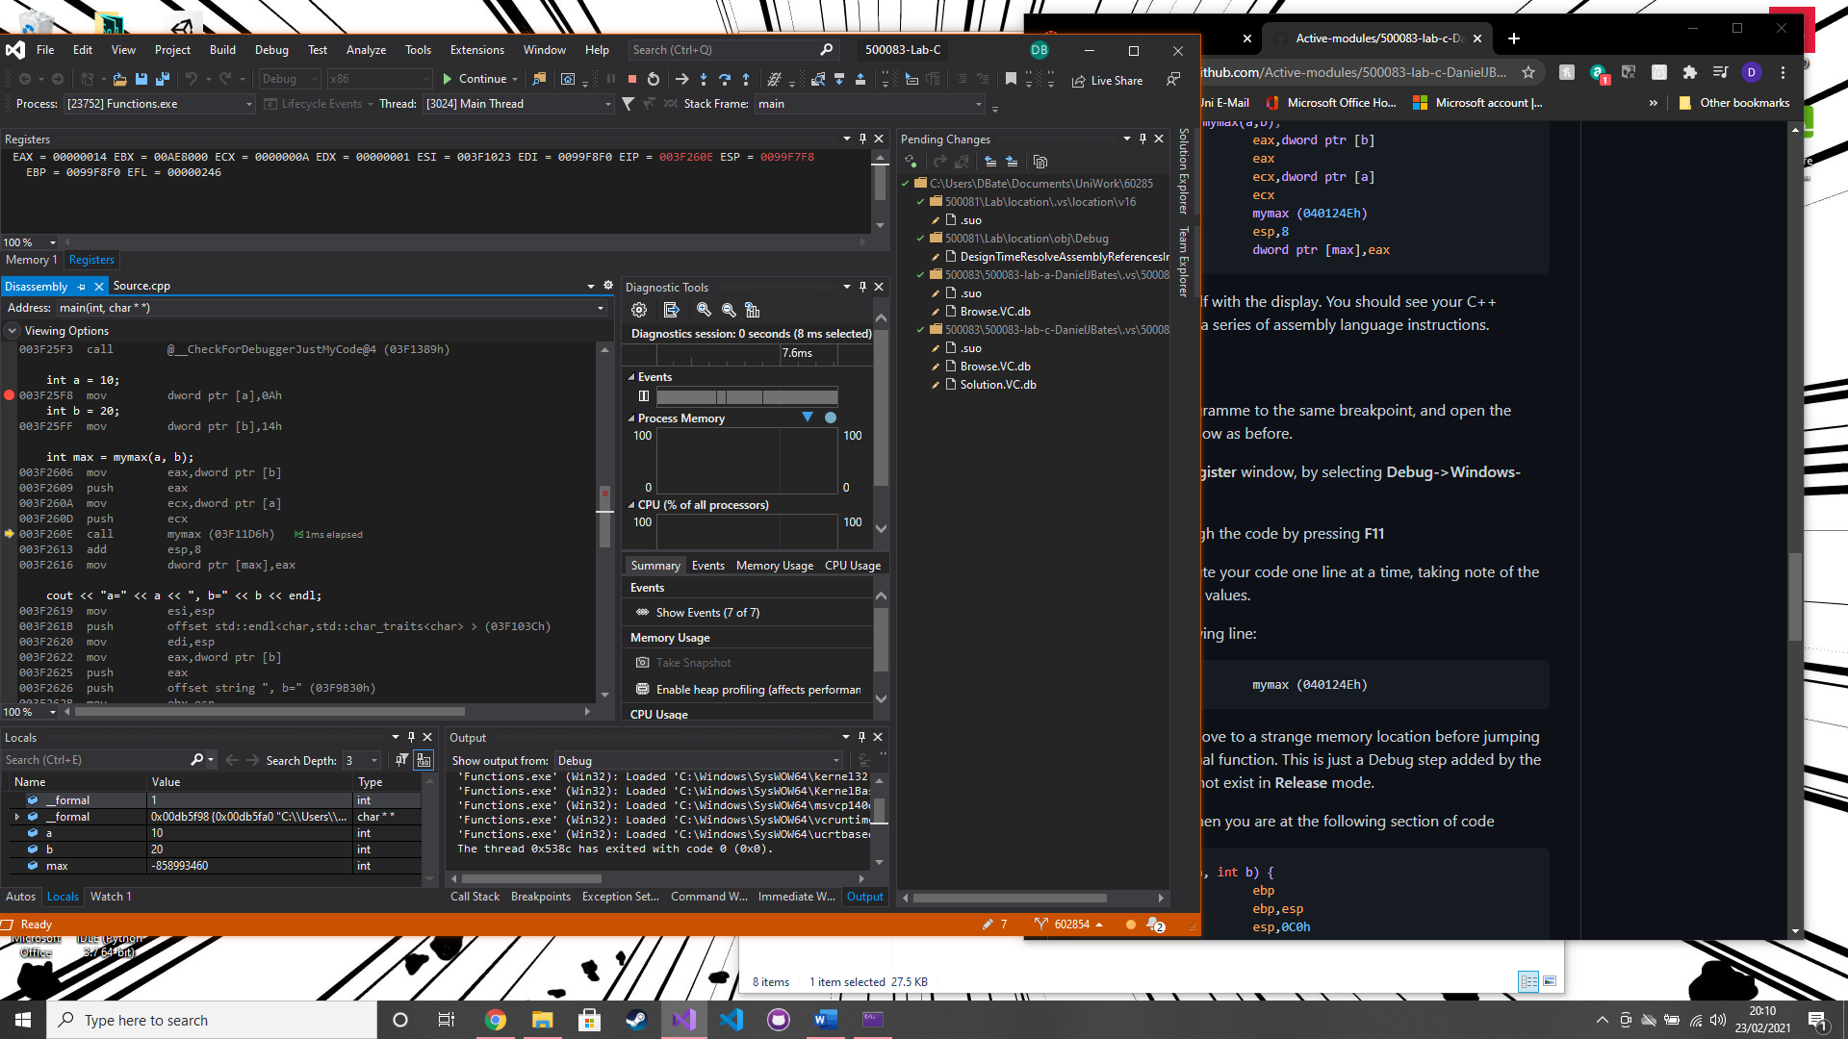

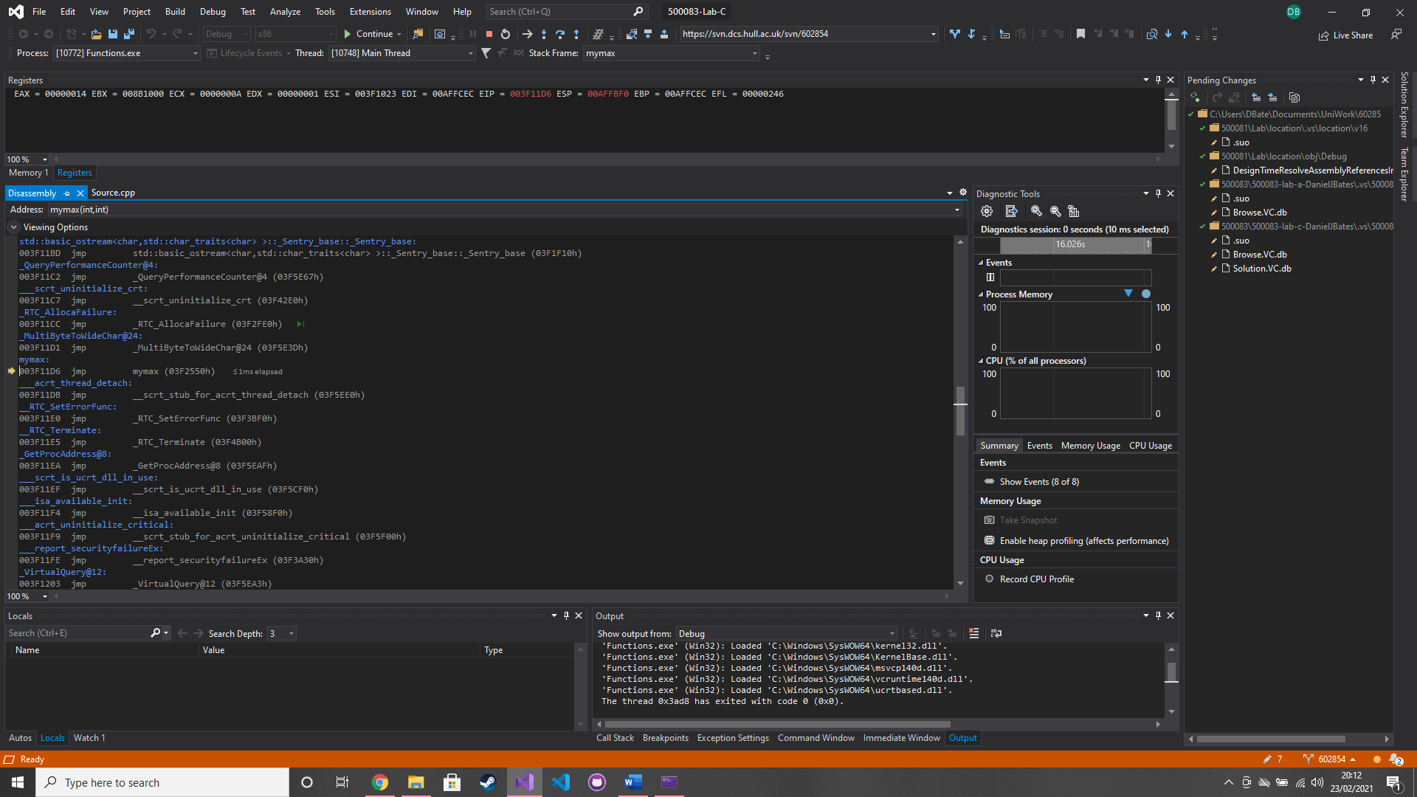

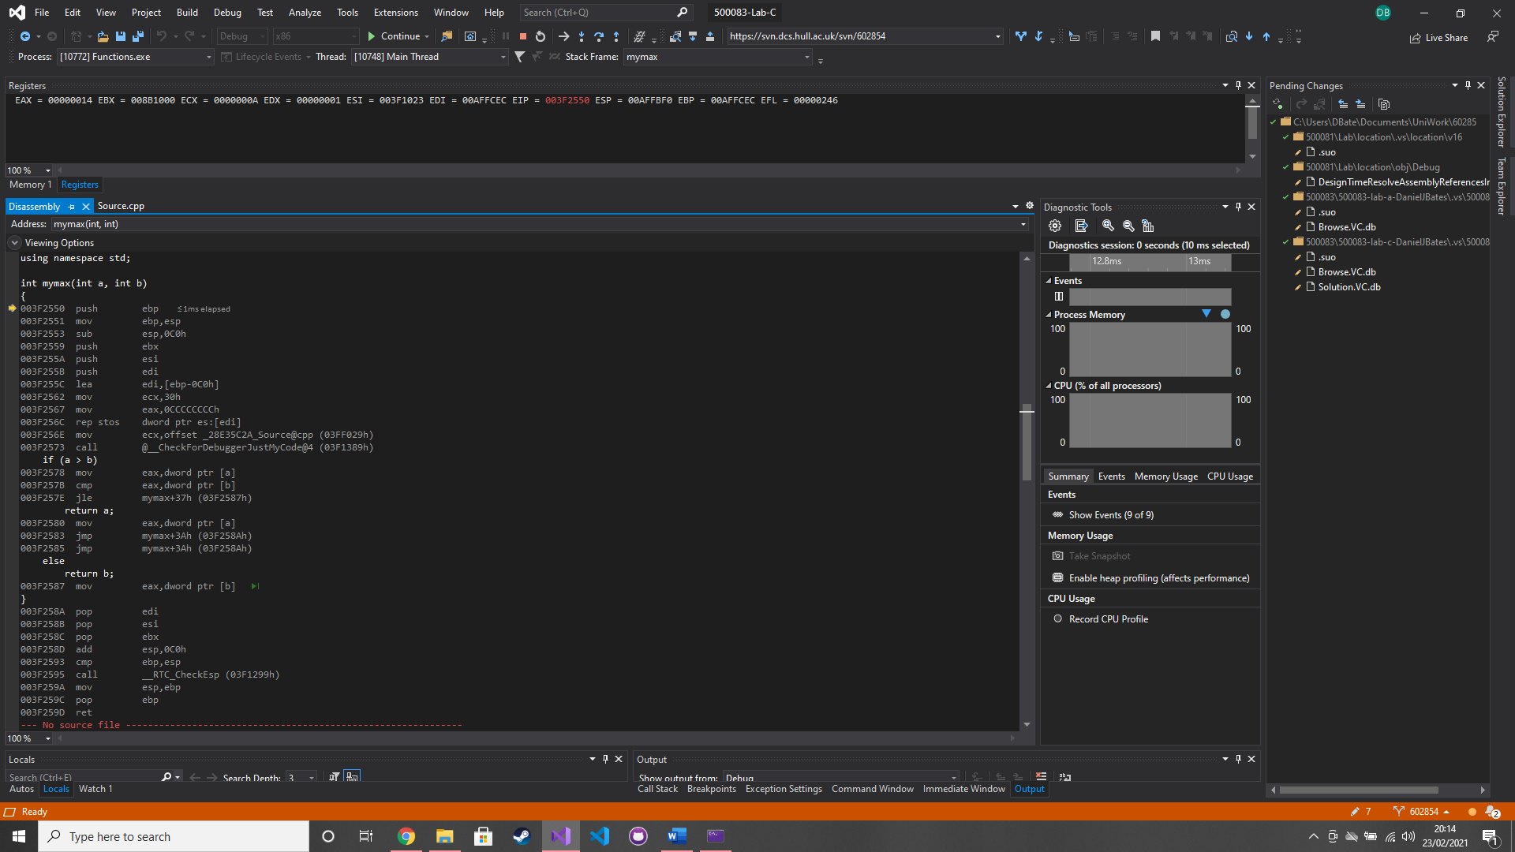

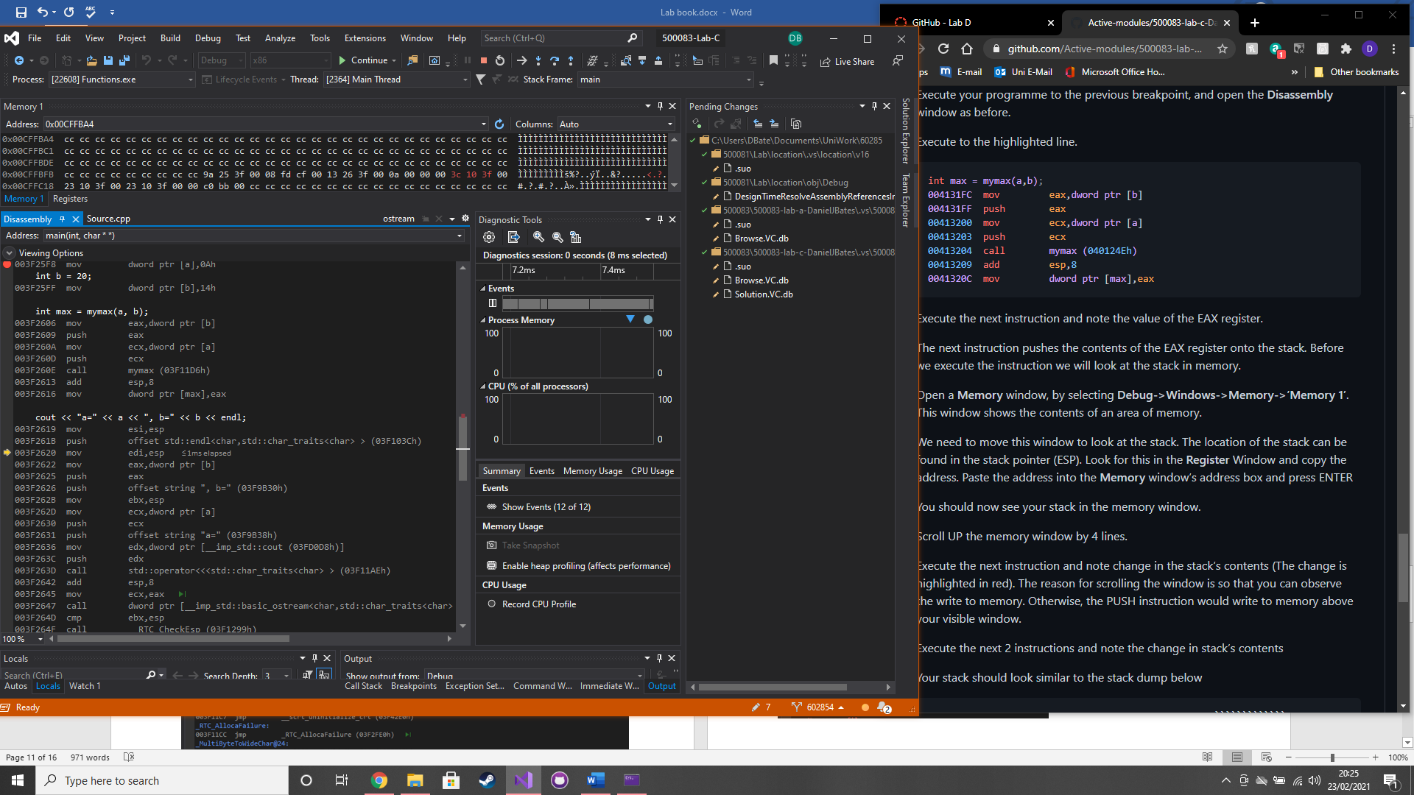

### Test data:

n/a

### Sample output:

n/a

### Reflection:

If the solutions platform is set to x64 instead of x86 then the assembly will look a lot different. 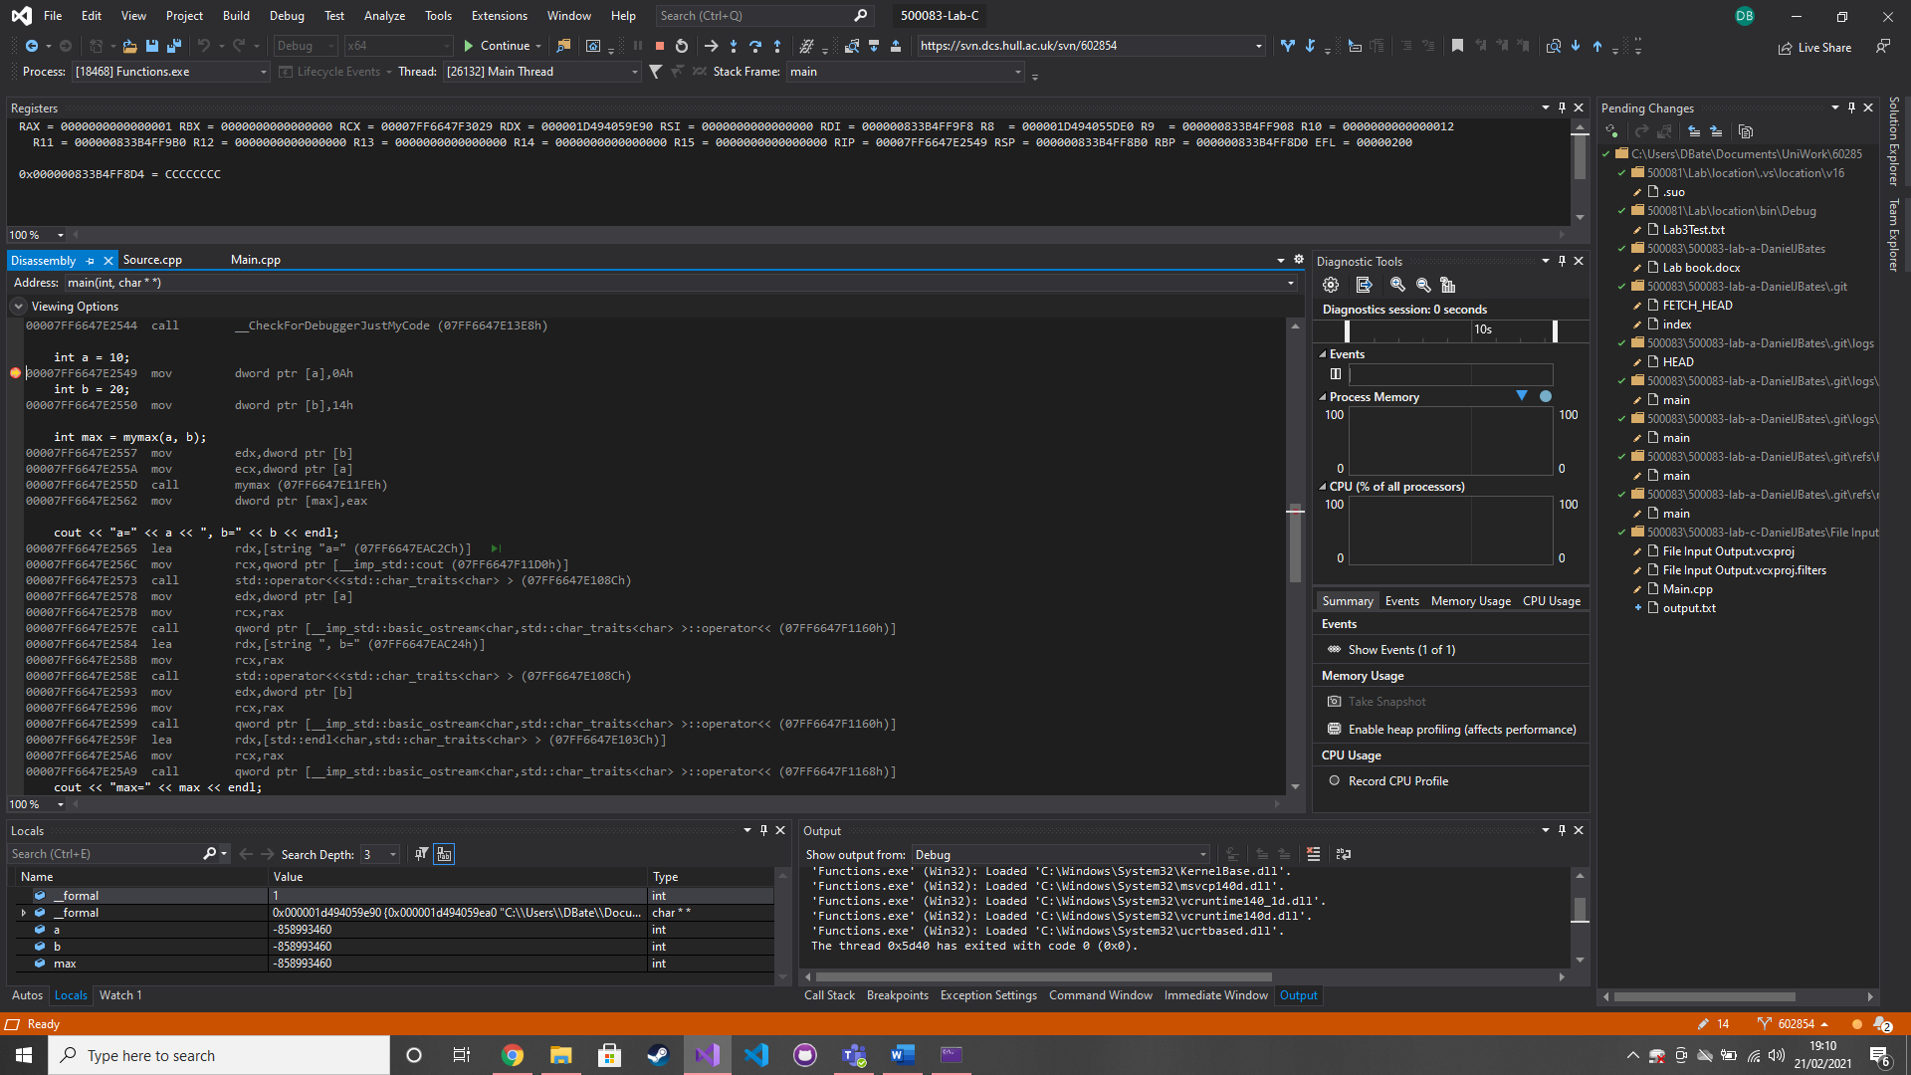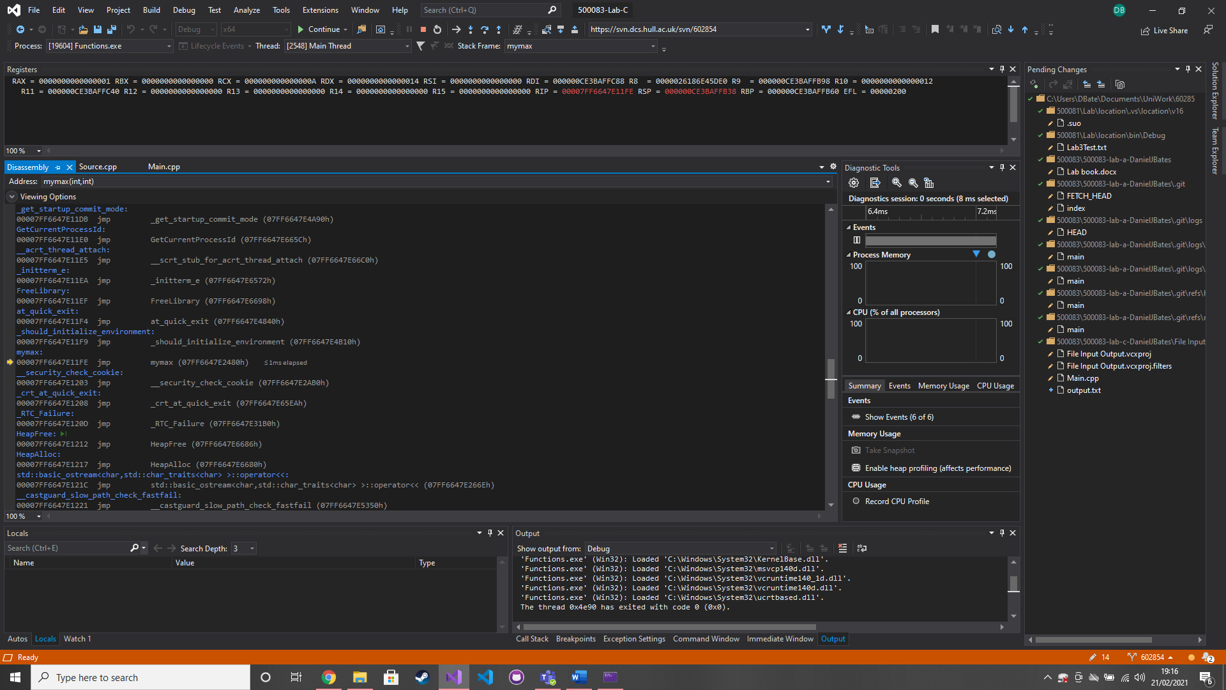

### Metadata:

Functions in assembly language

### Further information:

n/a

# Week 4 – Lab D

Date: 22/02/2021

### Q1. Linker errors

### Question:

Create a class named Grid and add in the provided code. Now add a new item this can be called Main.cpp and add the provided code. Compile the code and take a look at the linker errors. Add the provided code to fix these errors.

### Solution:

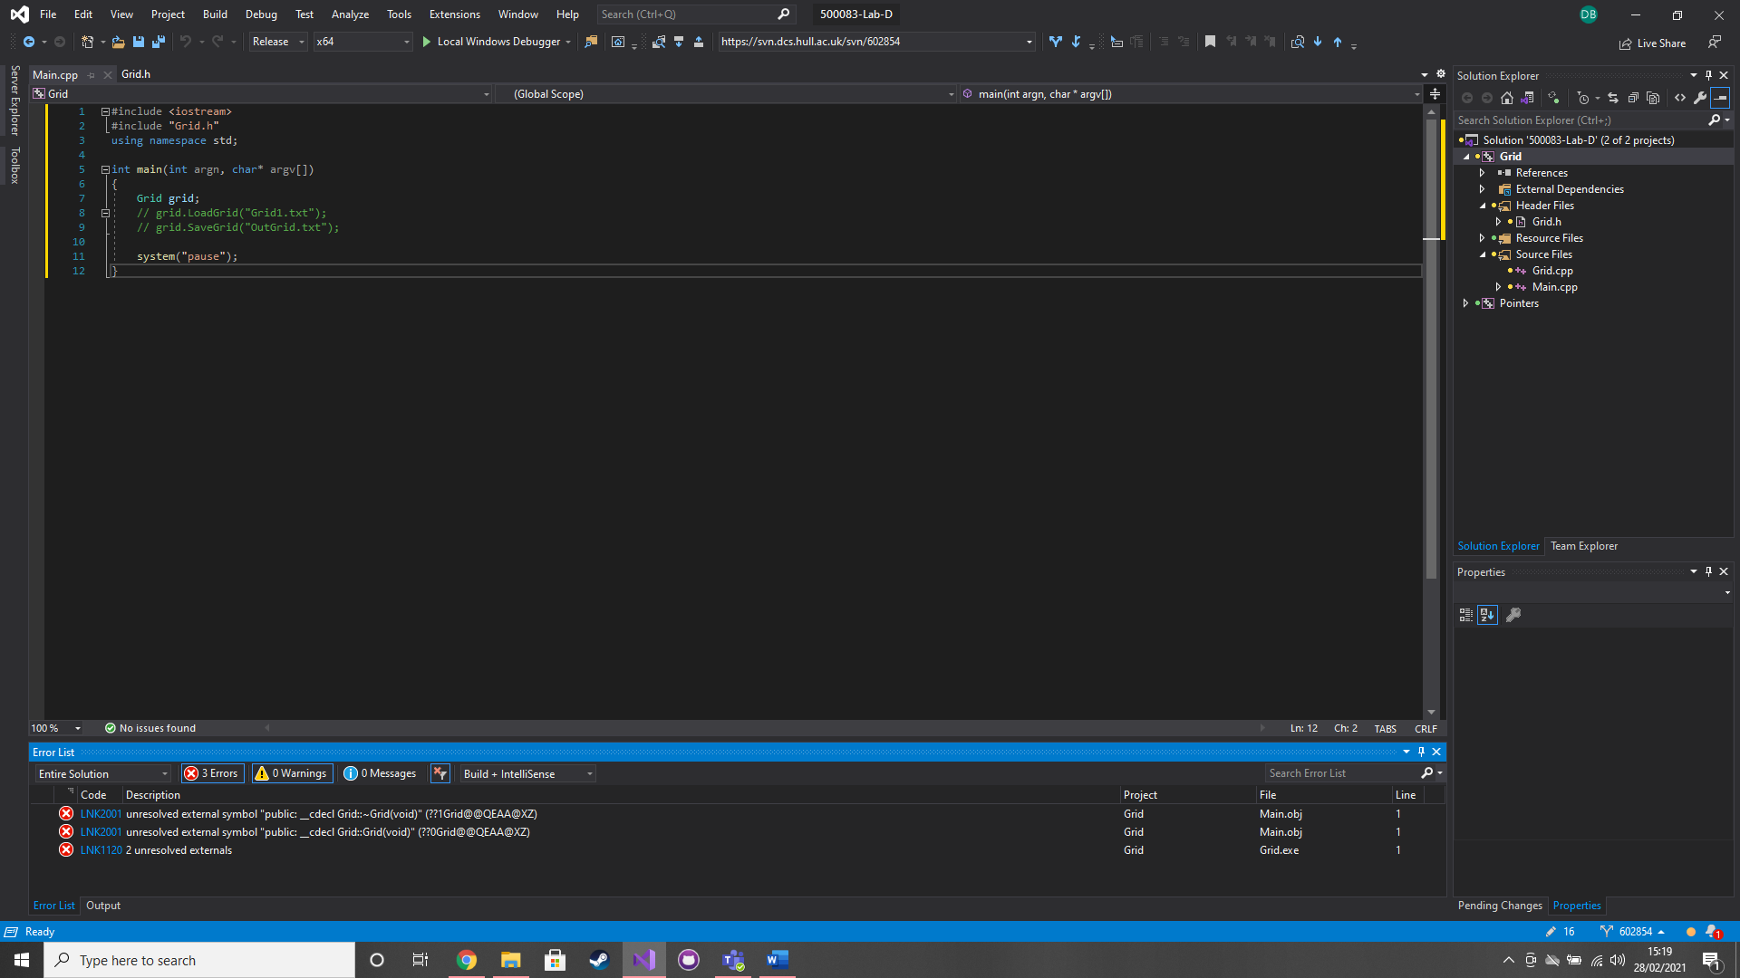

### Test data:

n/a

### Sample output:

n/a

### Reflection:

A .h needs to have a prototype for the constructor and destructor. The class .cpp file needs to contain the source code for a constructor and destructor.

### Metadata:

Linkers

### Further information:

n/a

### Q2. Reading into grid class

### Question:

Remove the comments on the line containing the LoadGrid method and try to compile the code.

### Solution:

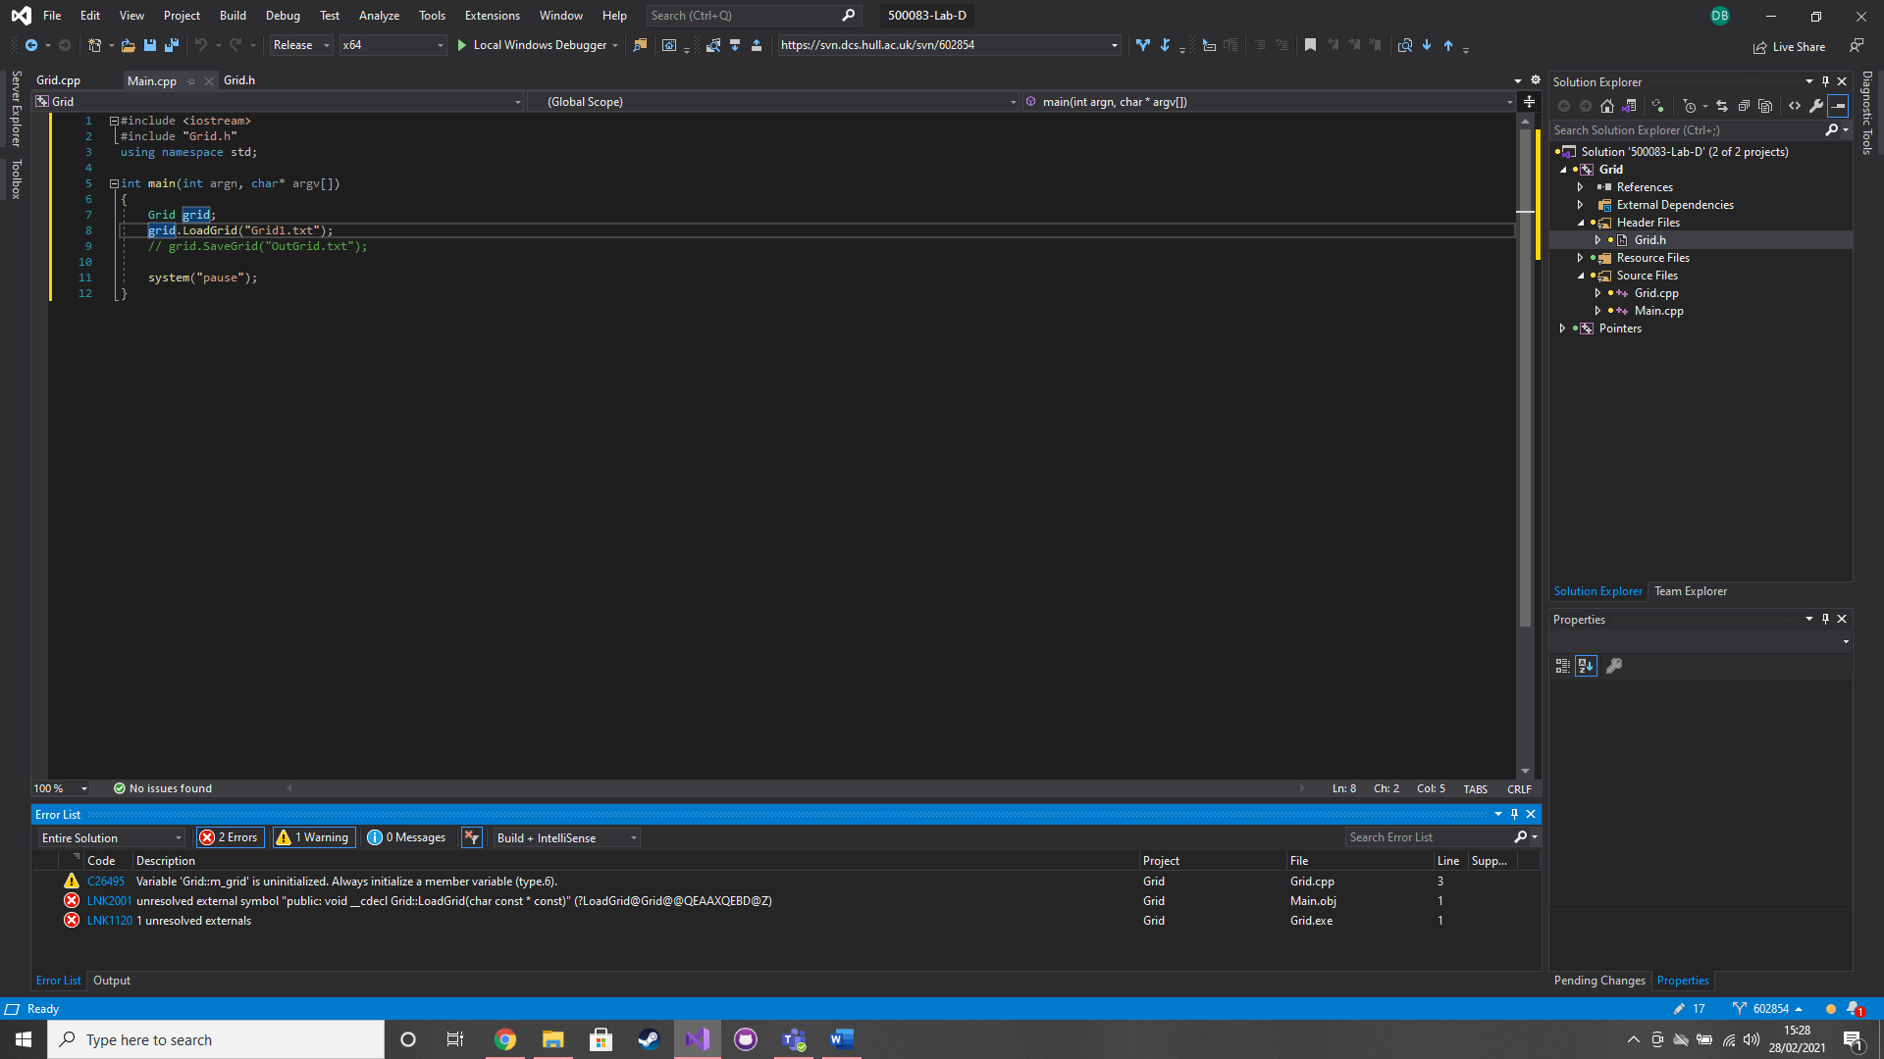

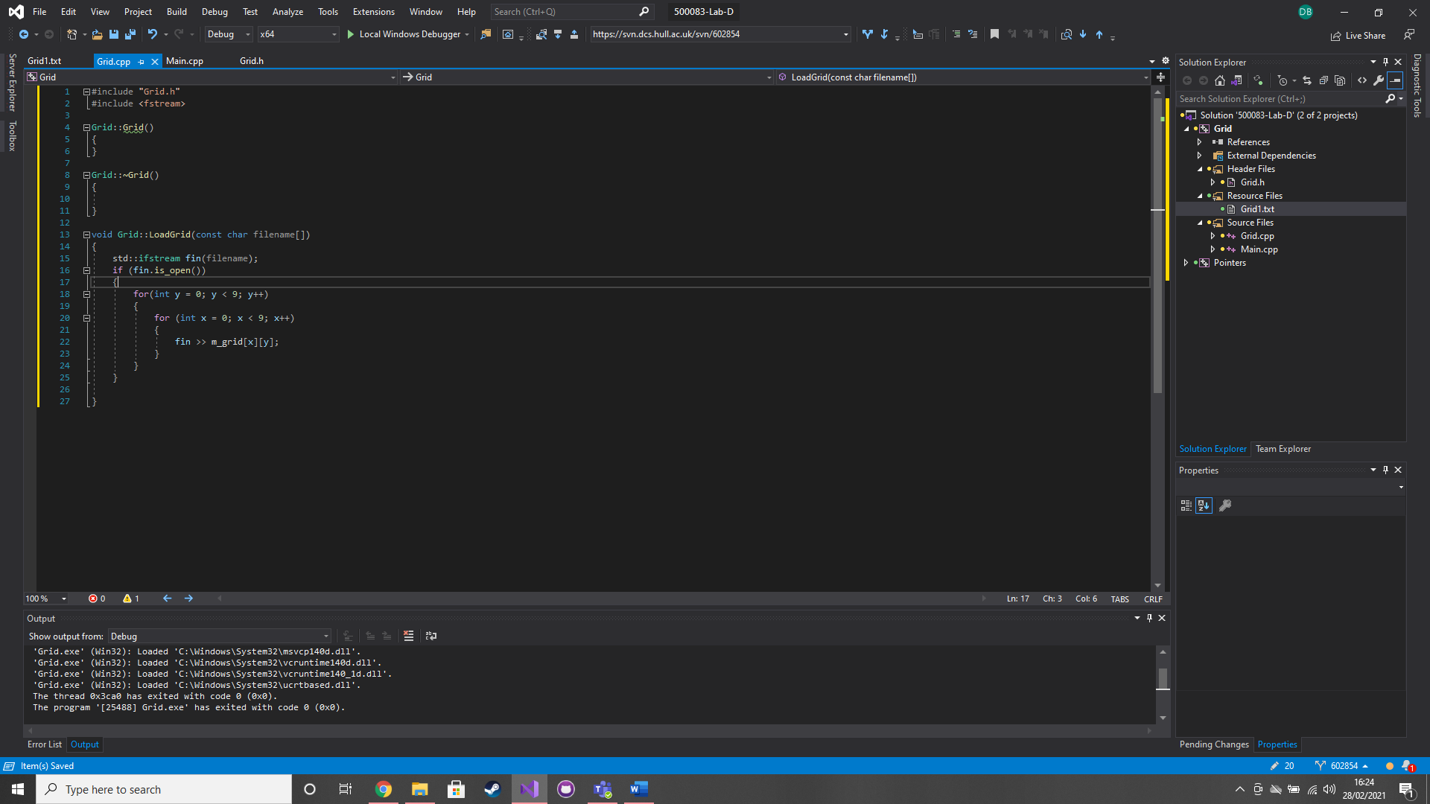

### Test data:

Grid1.txt

### Sample output:

m_grid is the same as the text file

### Reflection:

Its pretty similar to c#

I need to find out how I can get the length of a 2d array in c++

### Metadata:

Reading into a grid

### Further information:

n/a

### Q3. Saving the grid

### Question:

Implement the SaveGrid method. Do not overwrite Grid1.txt

### Solution:

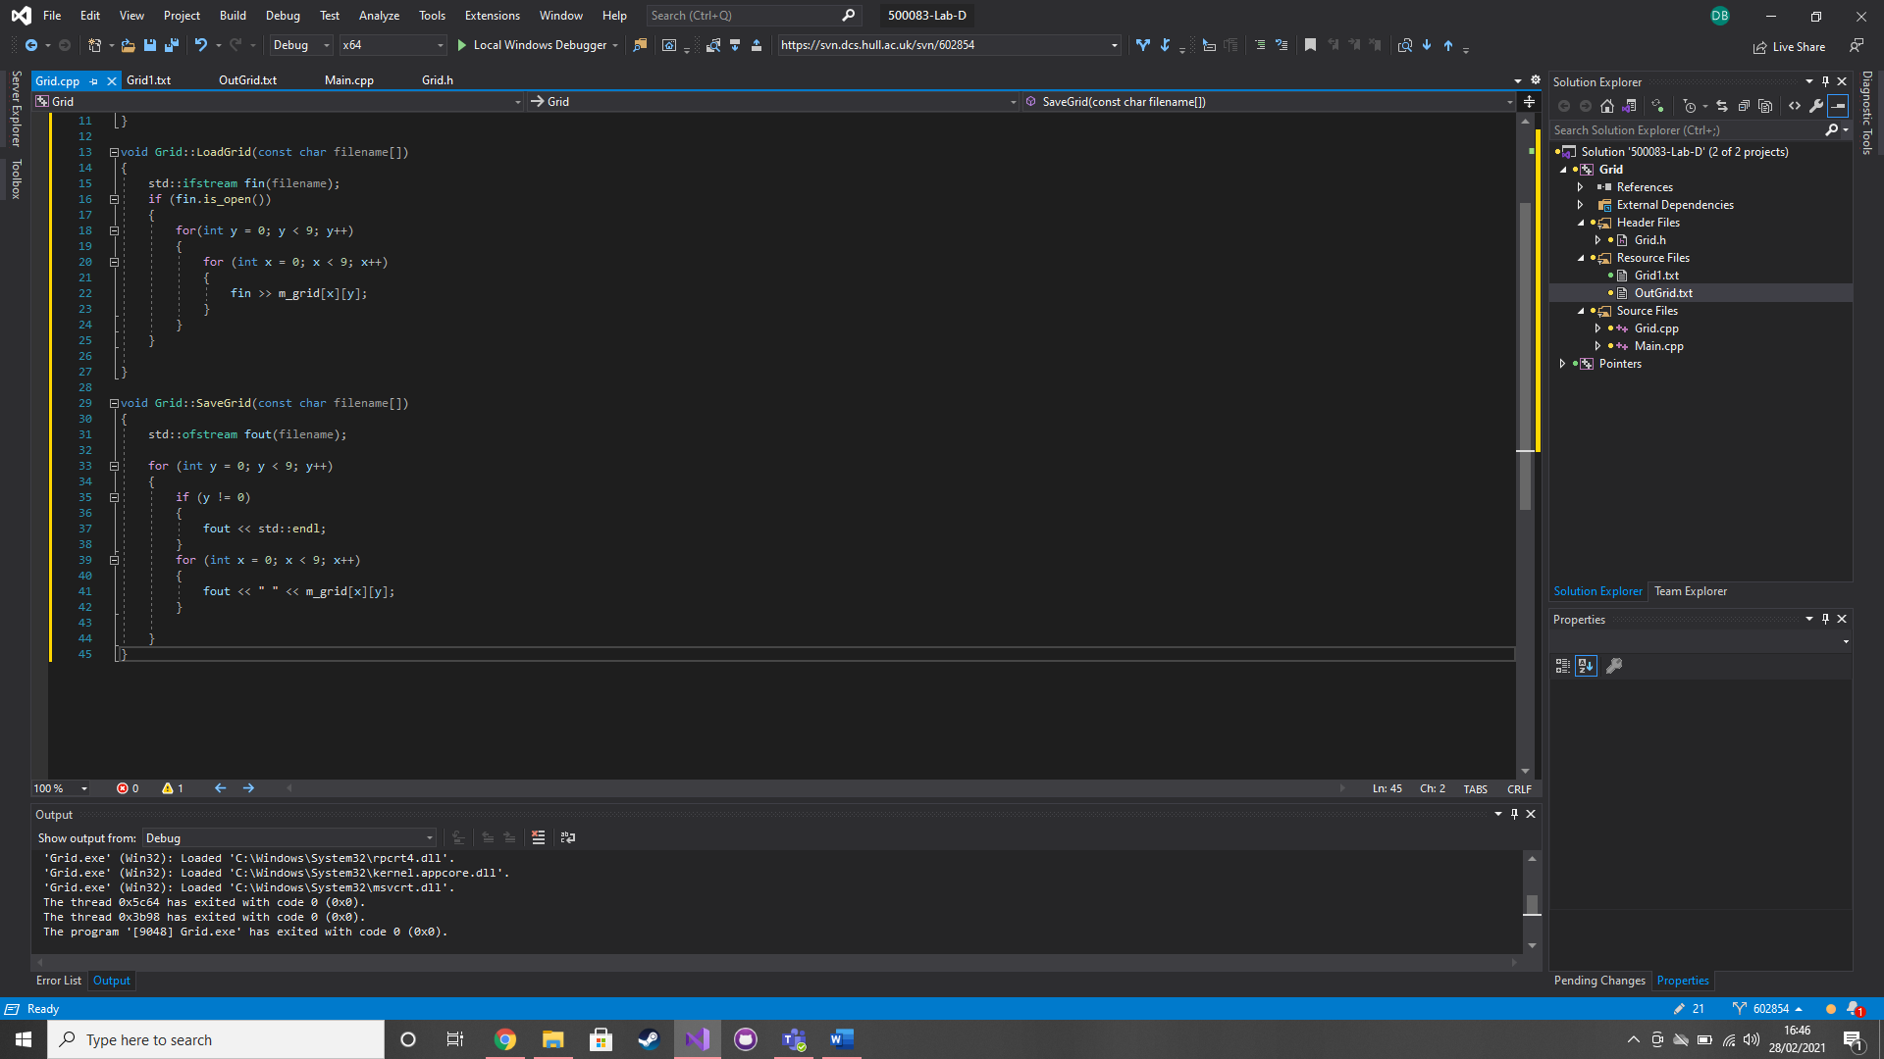

### Test data:

m_grid

### Sample output:

OutGrid.txt is the same as m_grid

### Reflection:

This is pretty much the same as copying just using fout instead of fin.

Endl must be done before the second loop if its not the first time going through to get the correct number of lines in the .txt

### Metadata:

Save a grid

### Further information:

n/a

### Q4. Pointers - Basics

### Question:

In FunctionA set a to 100 using the pointer. Set a breakpoint on “int a = 10”

### Solution:

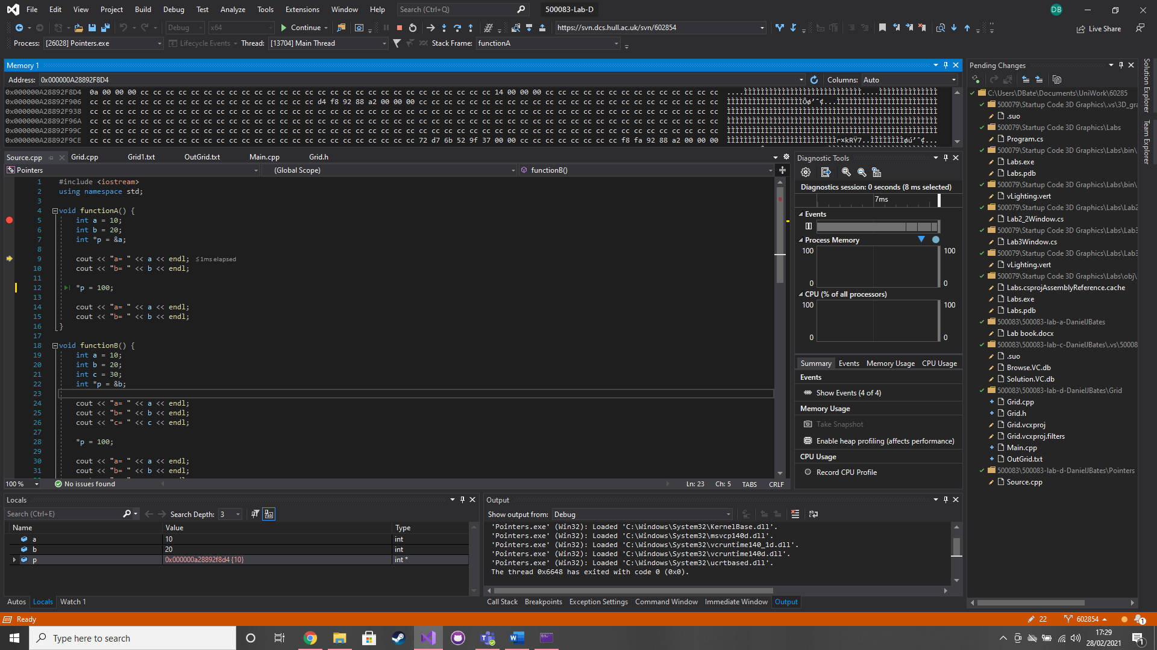

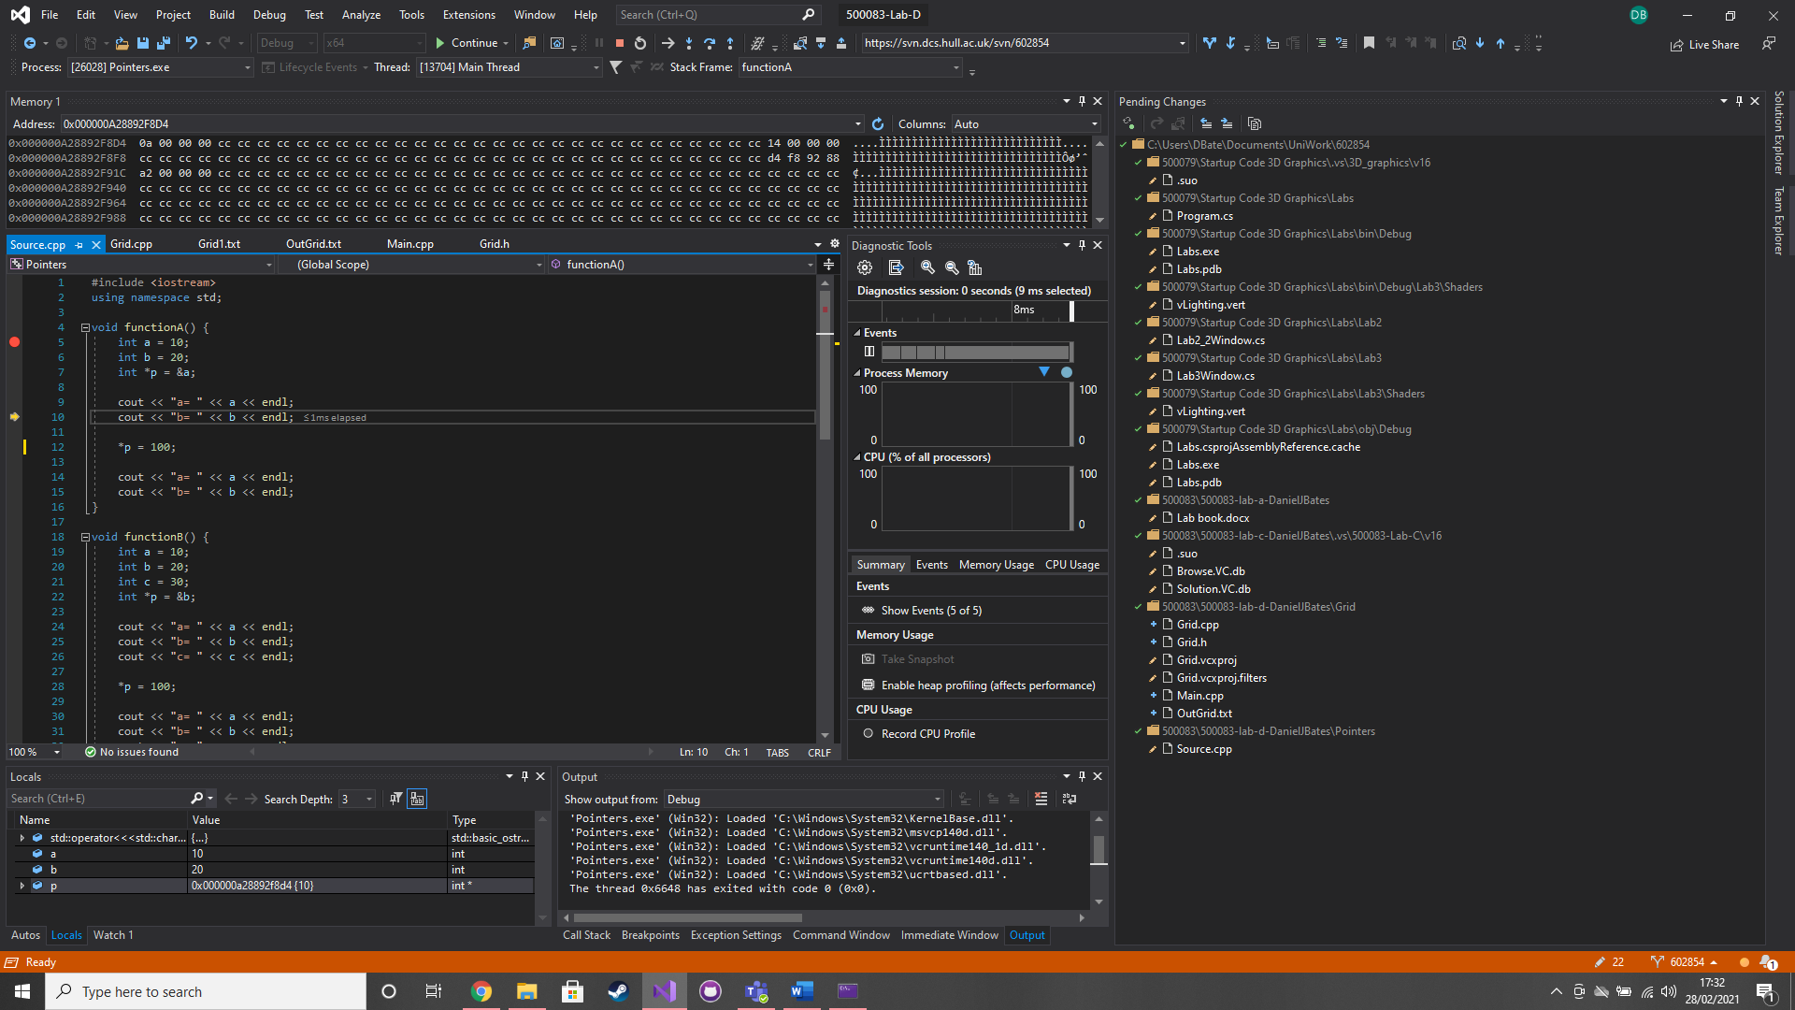

### Test data:

### Sample output:

### Reflection:

*p is set the a hexadecimal value which is the memory address of a

### Metadata:

Pointers

### Further information:

n/a

### Q5. Pointers – False assumptions

### Question:

Comment out FunctionA and uncomment FunctionB. Compile and run then observe the results. After the line “*p = 100;” add “p++; *p = 200;”.

### Solution:

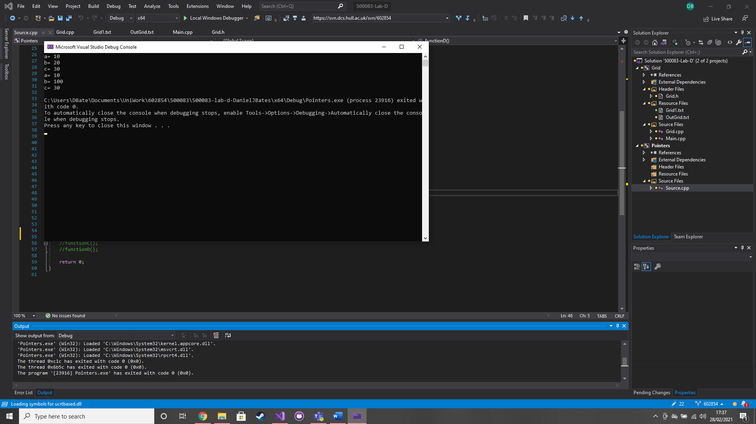

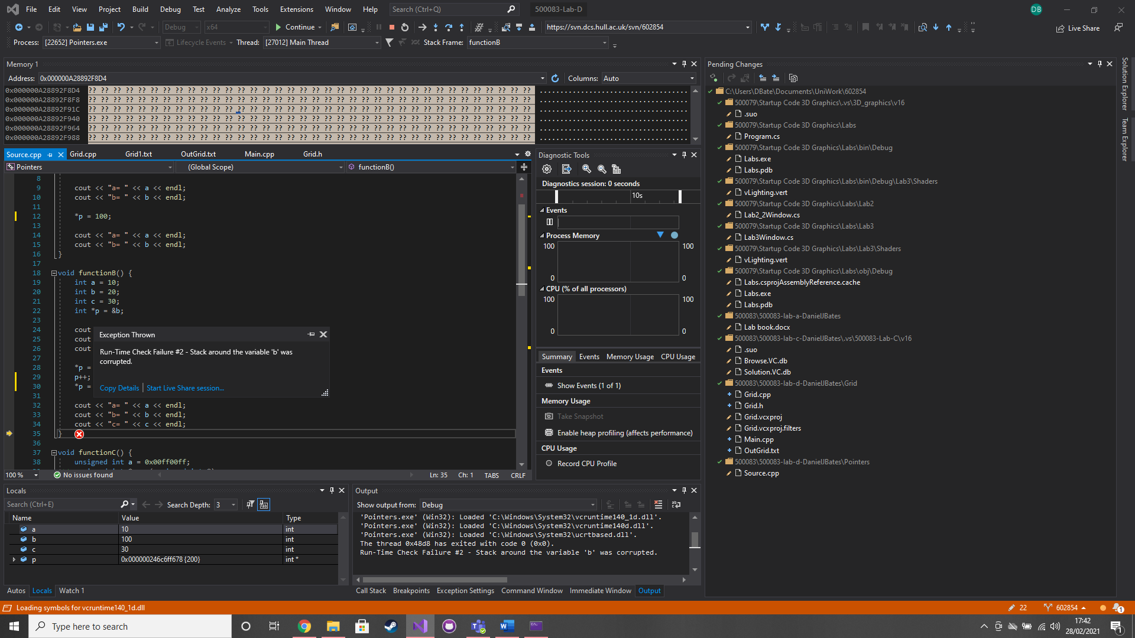

### Test data:

n/a

### Sample output:

n/a

### Reflection:

Just because we list variables sequentially in our programme, does not guarantee that the compiler places them contiguously in memory.

Arrays can be used to guarantee memory layout

### Metadata:

Pointer errors

### Further information:

n/a

### Q6. Pointers – The crash

### Question:

Comment out FunctionB and uncomment FunctionC. Compile and run. Set a breakpoint and find the reason for the crash.

### Solution:

### 

### Test data:

n/a

### Sample output:

n/a

### Reflection:

Windows prevents applications from accessing memory outside of its permitted memory footprint

### Metadata:

Crash

### Further information:

n/a

### Q7. Pointers – Pointers to pointers

### Question:

Comment out FunctionC and uncomment FunctioD. Recreate the pointer chain in the diagram provided. 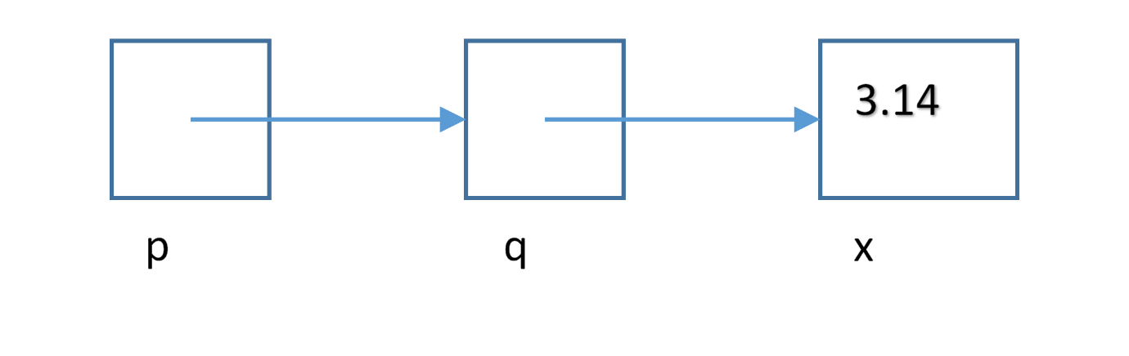

### Solution:

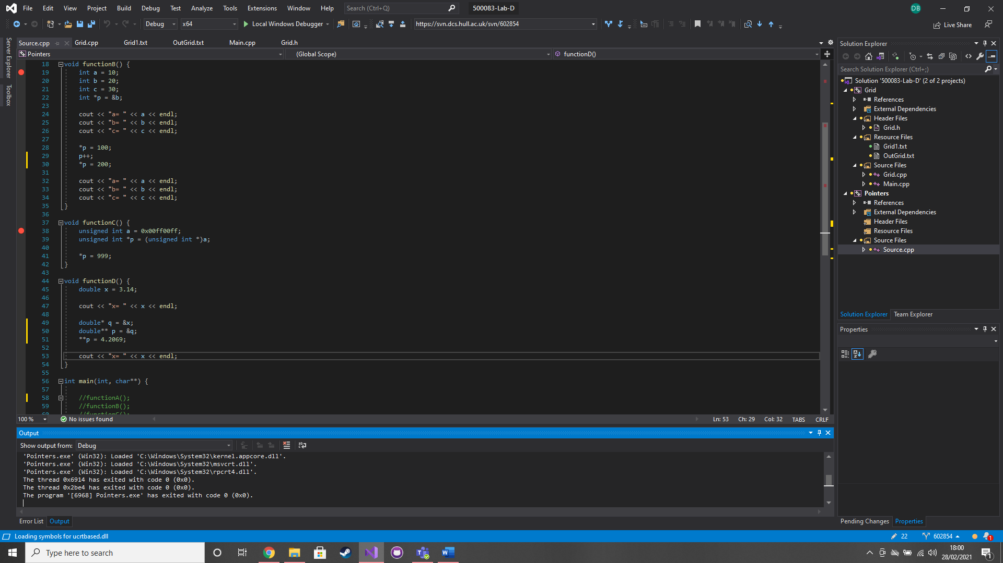

### Test data:

n/a

### Sample output:

X = 3.14

X = 4.2069

### Reflection:

If you are going to point to a pointer you need to use **

### Metadata:

Pointer chain

### Further information:

n/a

### Q8. Pointers – Pointer chain (Optional)

### Question:

Implement a pointer chain loop like the diagram provided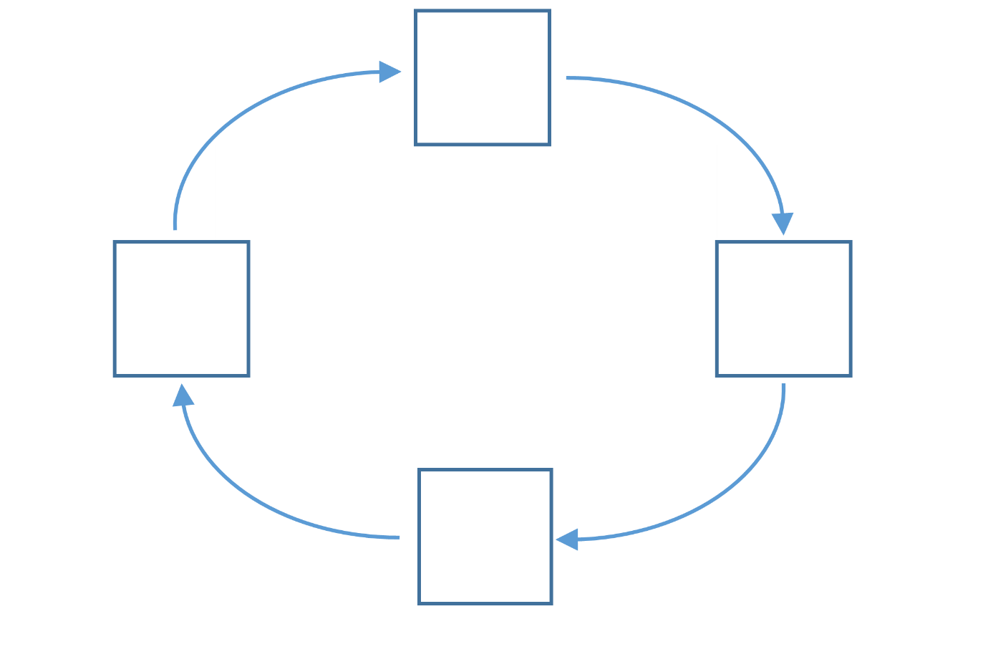

### Solution:

Double ***c;

Double ****z = &c;

Double *p = (double *)&z;

Double **q =&p;

C=&q;

Void *

### Test data:

### Sample output:

### Reflection:

This would be pointless. It would be like a while(true) loop will no break

### Metadata:

Pointer chain loop

### Further information:

n/a

# Week 5 – Lab E

Date: 01/03/2021

### Q1. Operators in Grid

### Question:

Extend your code from Q2 and Q3 in Lab D. add the functionality to write the Grid to an ostream using the auxiliary operator<< and the functionality to read in the values from an istream into the Grid using the auxiliary operator>>

### Solution:

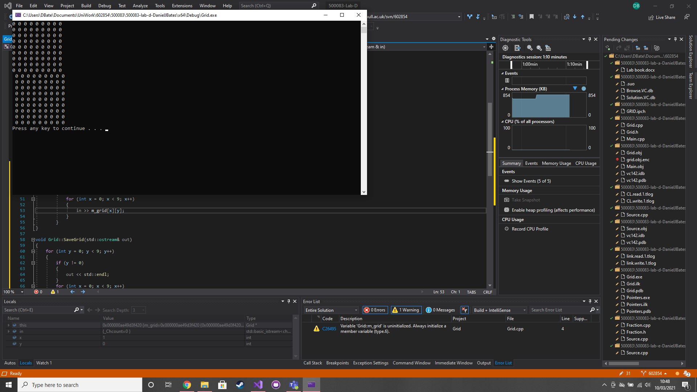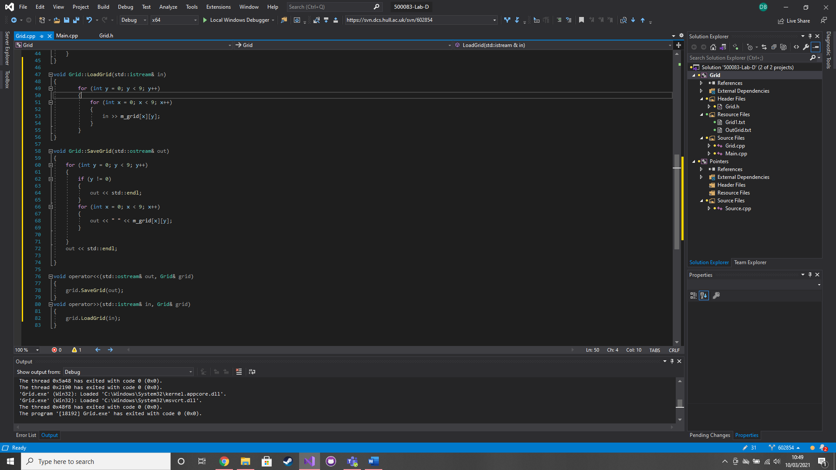

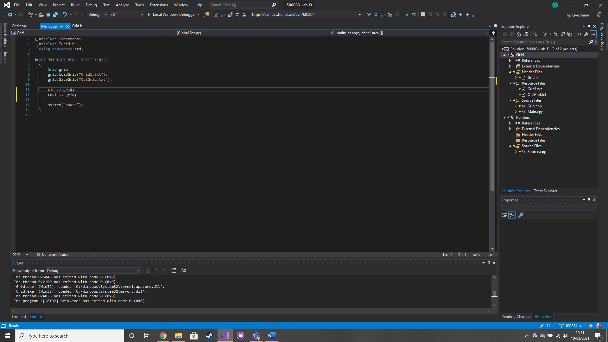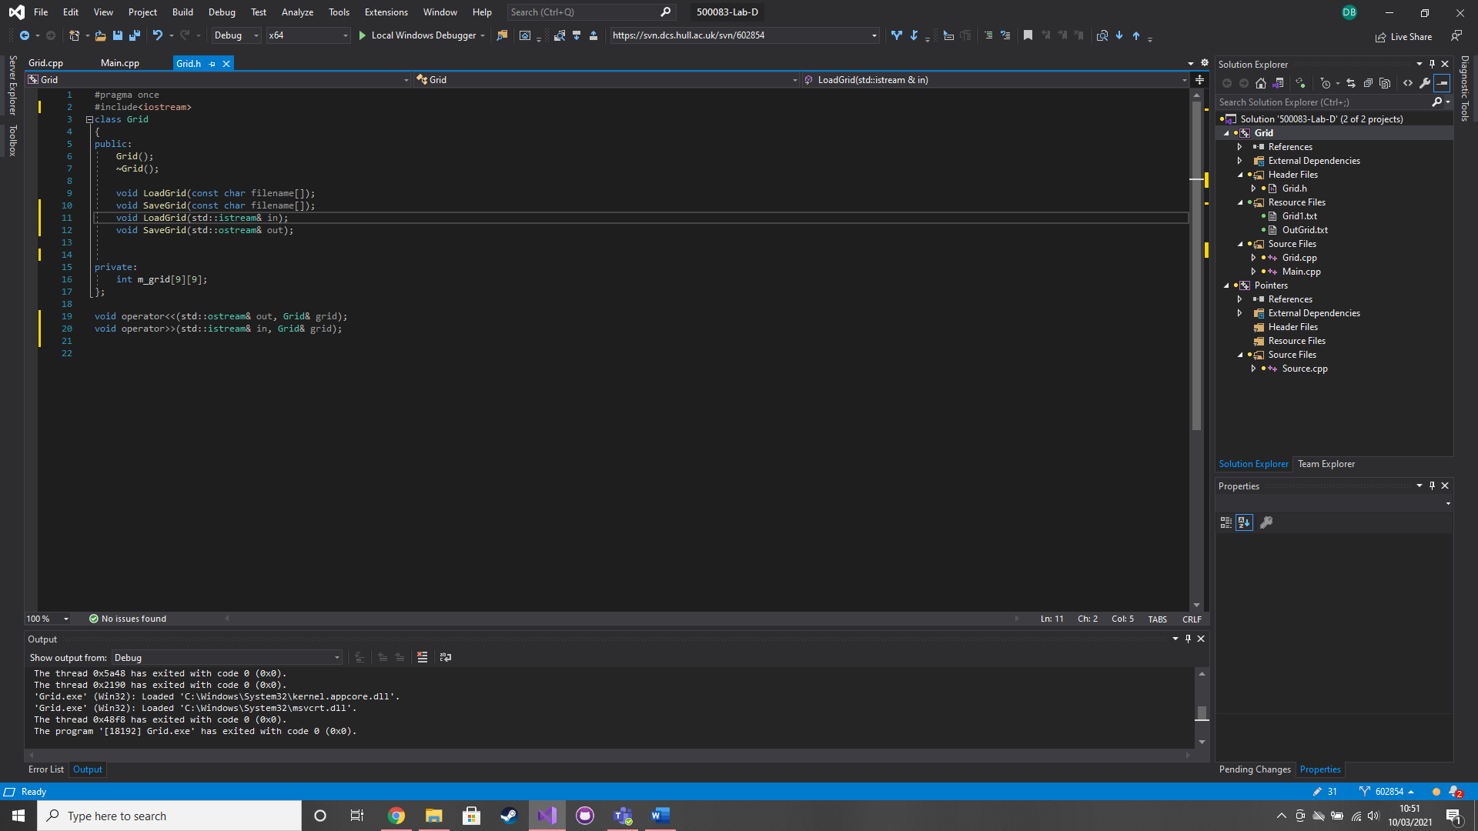

### Test data:

0 0 0 0 0 0 0 0 0

0 0 0 0 0 0 0 0 0

0 0 0 0 0 0 0 0 0

0 0 0 0 0 0 0 0 0

0 0 0 0 0 0 0 0 0

0 0 0 0 0 0 0 0 0

0 0 0 0 0 0 0 0 0

0 0 0 0 0 0 0 0 0

### Sample output:

0 0 0 0 0 0 0 0 0

0 0 0 0 0 0 0 0 0

0 0 0 0 0 0 0 0 0

0 0 0 0 0 0 0 0 0

0 0 0 0 0 0 0 0 0

0 0 0 0 0 0 0 0 0

0 0 0 0 0 0 0 0 0

0 0 0 0 0 0 0 0 0

### Reflection:

This is simpler than I was thinking it to be. I have to adapt the class functions to accommodate the new streaming operator.

### Metadata:

Streaming operators

### Further information:

n/a

### Q2. Fractions

### Question:

Implement the Fraction class that you have seen in lectures. Use the header file example that was presented in lectures to define your class, methods, member variables etc.

### Solution:

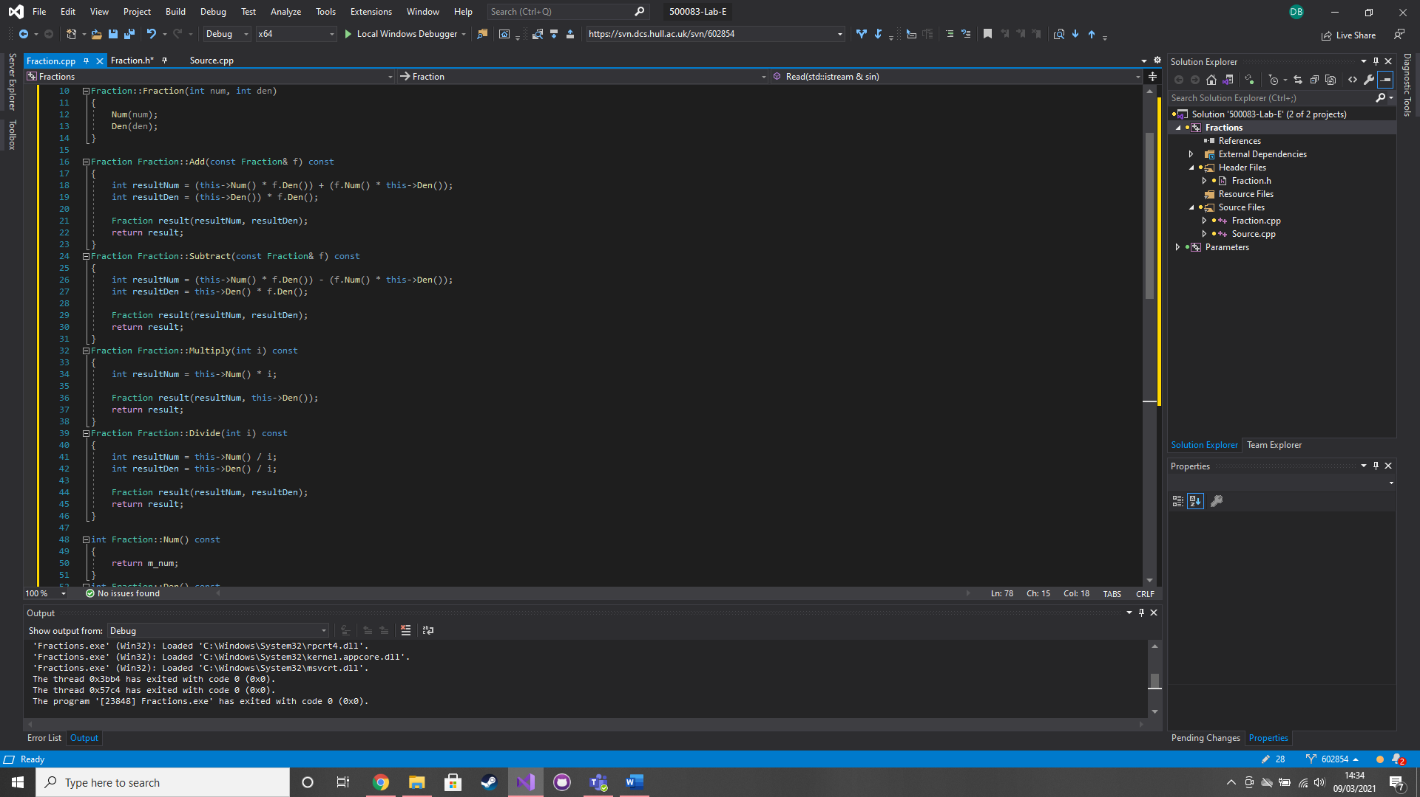

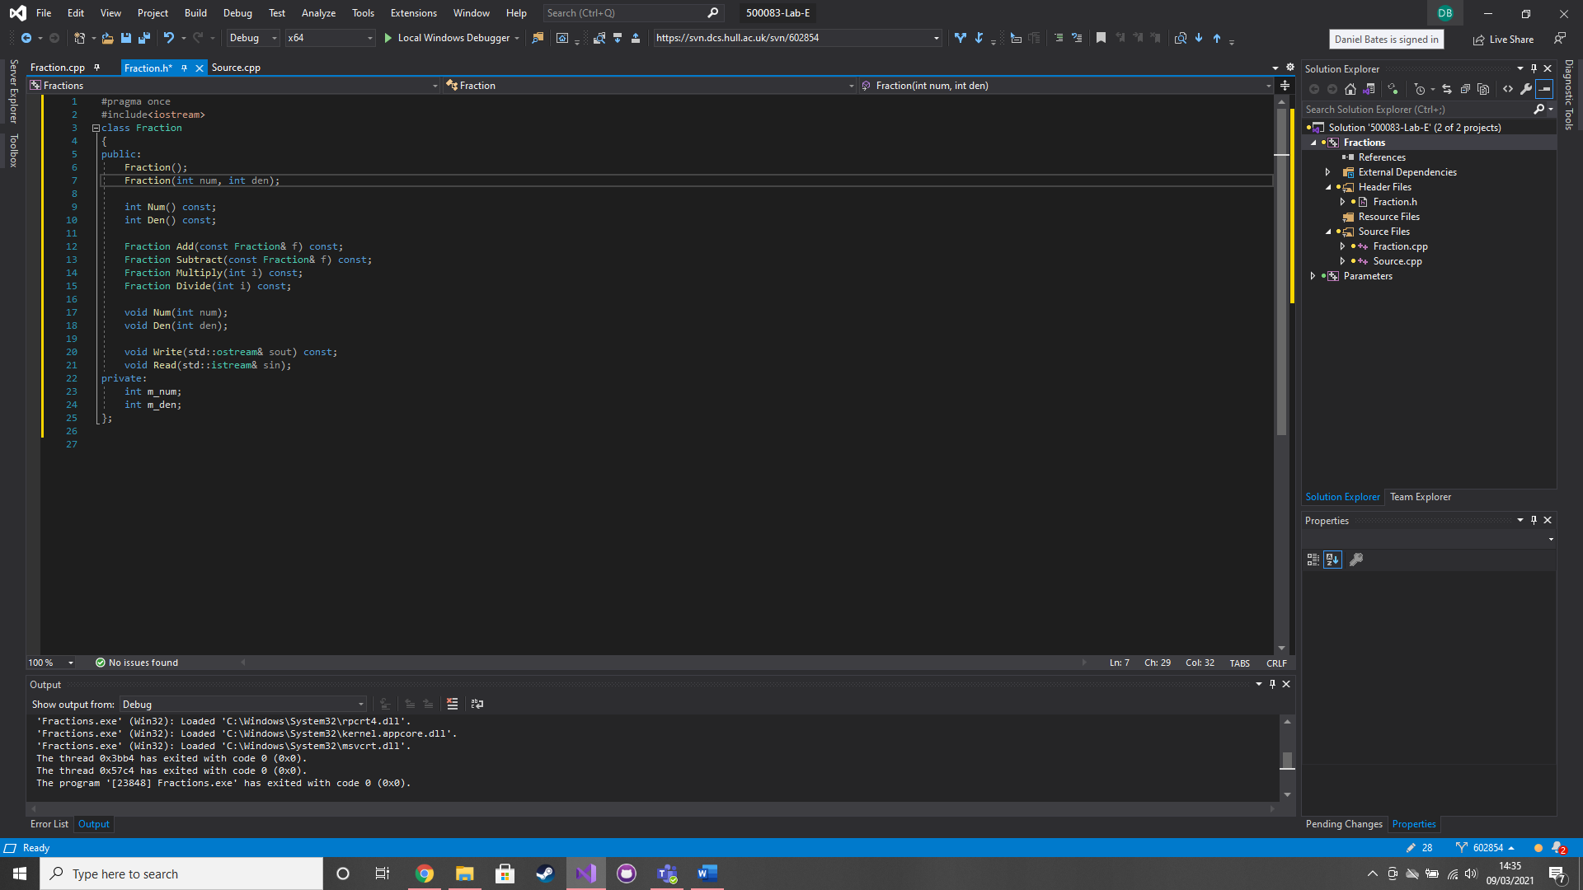

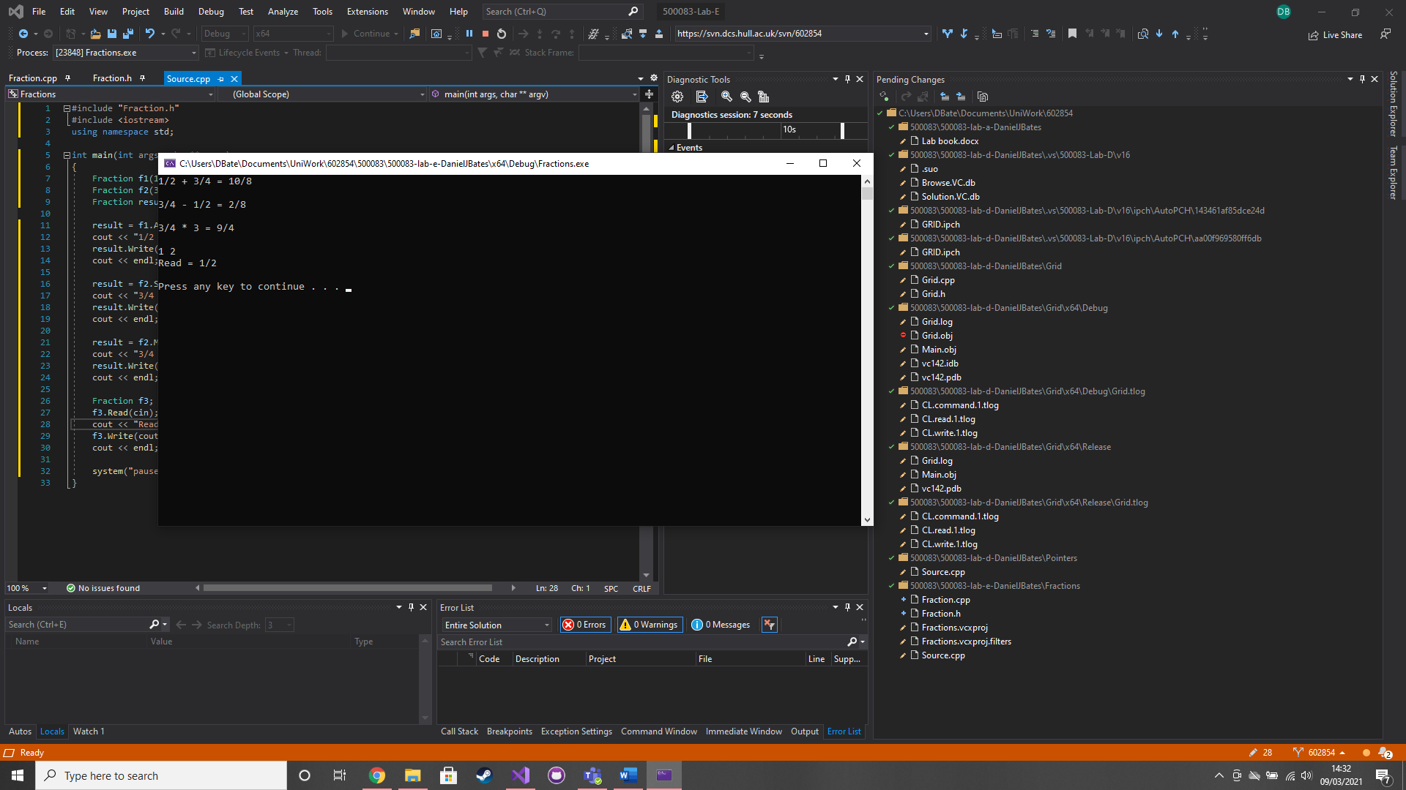

### Test data:

1 2

### Sample output:

Read = 1/2

### Reflection:

This is pretty simple as its fairly similar to C#. I just need to remember that I need to use things like ‘Fraction::’ in the .cpp

### Metadata:

Fraction class

### Further information:

n/a

### Q3. Operators in Fraction

### Question:

Implement a class member operator operator+, class member operator operator-, class member operator operator* and a auxiliary operator operator*.

### Solution:

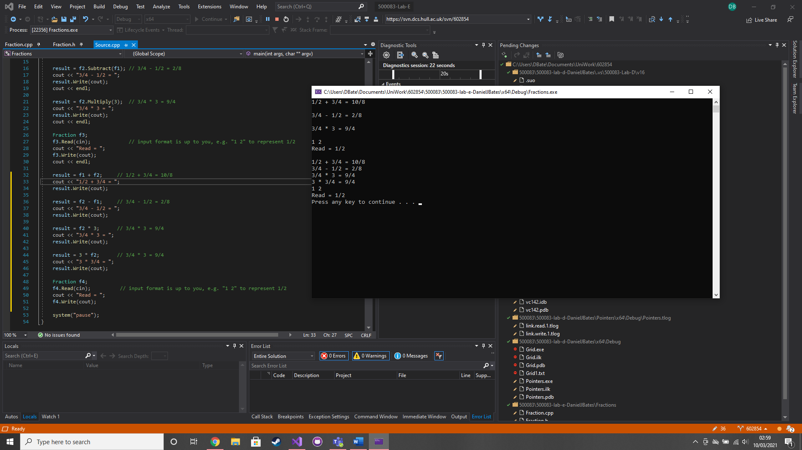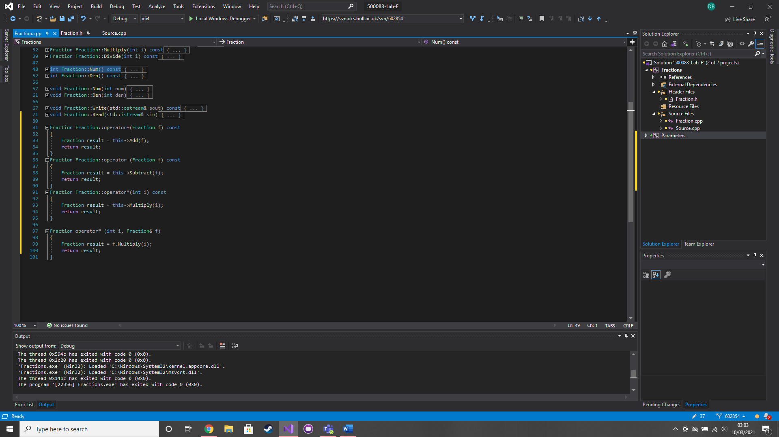

### Test data:

1 2

### Sample output:

Read = 1/2

### Reflection:

This is pretty straight forward although in a scenario like this I’m not sure why you would even bother if the class member operators, auxiliary seems so much better.

### Metadata:

Operators in fractions

### Further information:

n/a

### Q4. Parameters

### Question:

The goal is to swap the value of a and b. First place a breakpoint on ‘myswap(a,b);’ then run and open the disassembly, registers and memory. On memory set it to look at the stack. Step through the program and watch how the values of a and b are pushed onto the stack. Rewrite the previous code to pass the variables a and b into the myswap function by reference, rather than by value. Repeat the debugging process from the previous section. Find the address of a in the appropriate register, and use the address to look at the memory that holds the value for the variable a.

### Solution:

### Test data:

n/a

### Sample output:

n/a

### Reflection:

I understand the normal programming of this but I still don’t really get assembly language. This is just instead of making a copy of the passed in variable in the function it is just using the original variable.

### Metadata:

Passing by reference

### Further information:

n/a

### Q5. Return by value

### Question:

Replace the myswap function with the clamp function. Repeat the dissembling process but this time focus on the return value. Change the value parameter in clamp to be a reference, and repeat the disassembly process. Try the tests given to see if you get the correct answer.

### Solution:

### 

### Test data:

n/a

### Sample output:

n/a

### Reflection:

The function making a copy of the value to return. I understand the logic and code of it but the assembly language has me lost.

### Metadata:

Return by value

### Further information:

n/a

# Week 6 – Lab F

Date: 08/03/2021

### Q1. Template grid

### Question:

Turn the Grid class into a template class.

### Solution:

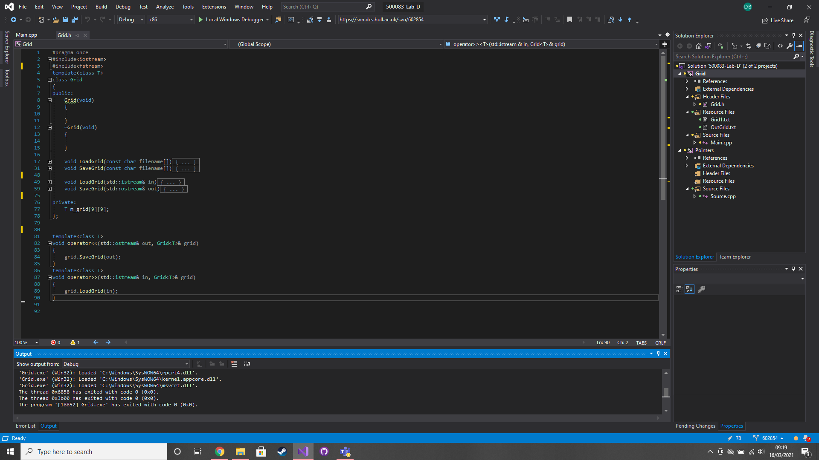

### Test data:

n/a

### Sample output:

n/a

### Reflection:

I can see how this could be useful so you wouldn’t need to make different functions for all the different types. E.g. int, float, double

### Metadata:

Template

### Further information:

n/a

### Q2. Template grid (floats)

### Question:

Change the code in main() so that you can store float values.

### Solution:

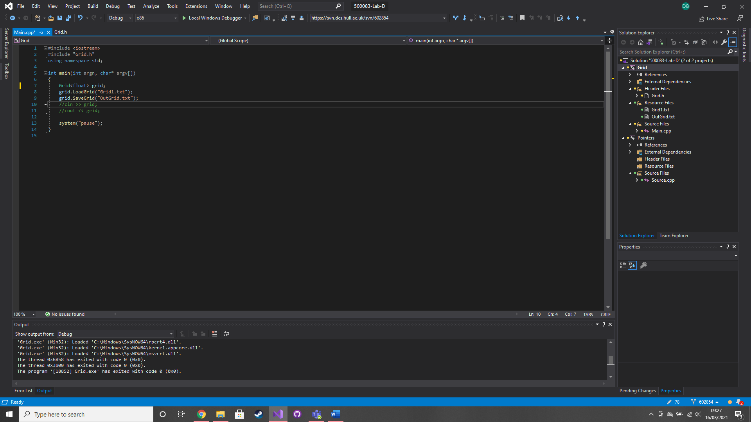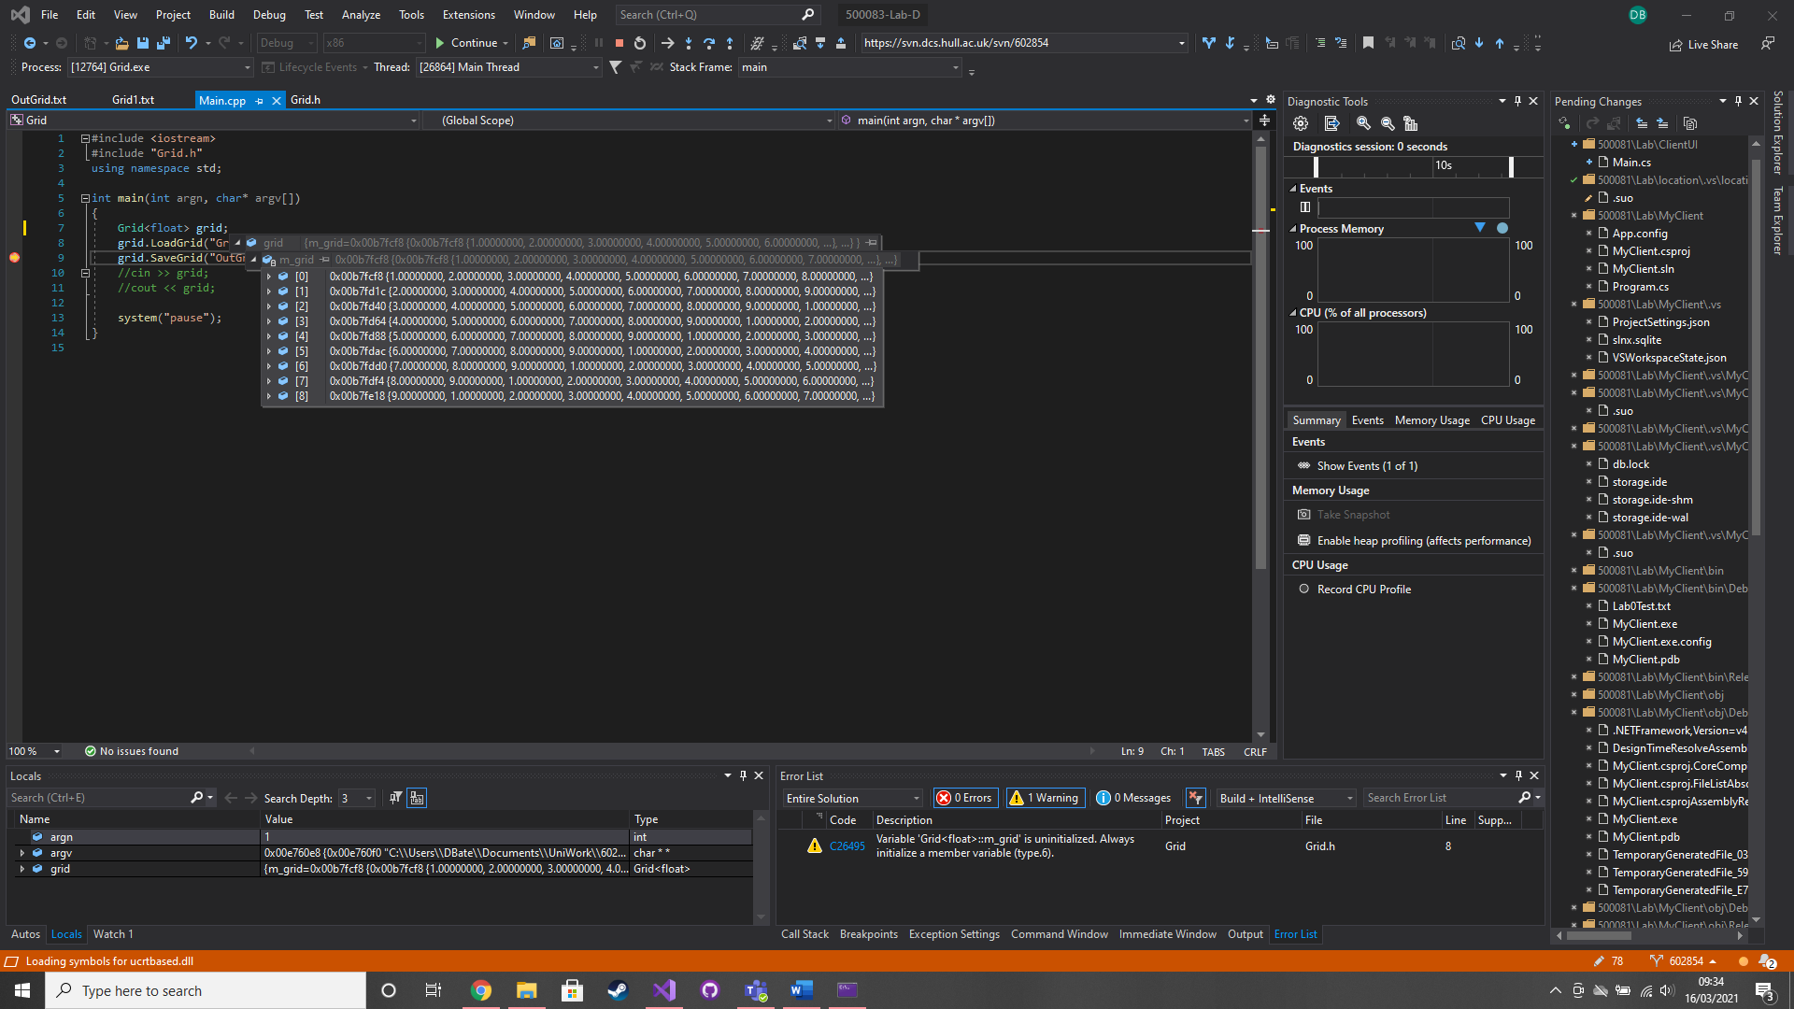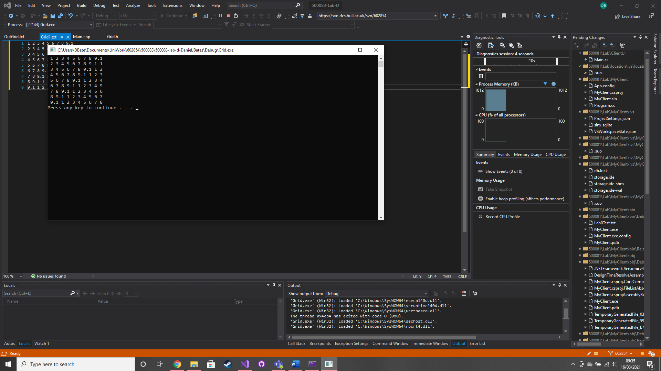

### Test data:

Changed all the 9’s in Grid1.txt to 9.1

### Sample output:

### 1 2 3 4 5 6 7 8 9.1

### 2 3 4 5 6 7 8 9.1 1

### 3 4 5 6 7 8 9.1 1 2

### 4 5 6 7 8 9.1 1 2 3

### 5 6 7 8 9.1 1 2 3 4

### 6 7 8 9.1 1 2 3 4 5

### 7 8 9.1 1 2 3 4 5 6

### 8 9.1 1 2 3 4 5 6 7

### 9.1 1 2 3 4 5 6 7 8

### Reflection:

Operator<< will convert a float such as 1.0 to an int implicitly because the .0 isn’t necessary.

### Metadata:

Grid<float>

### Further information:

n/a

### Q3. Binary search

### Question:

implement two versions of a binary search, one using iteration, the other using a recursive function.

### Solution:

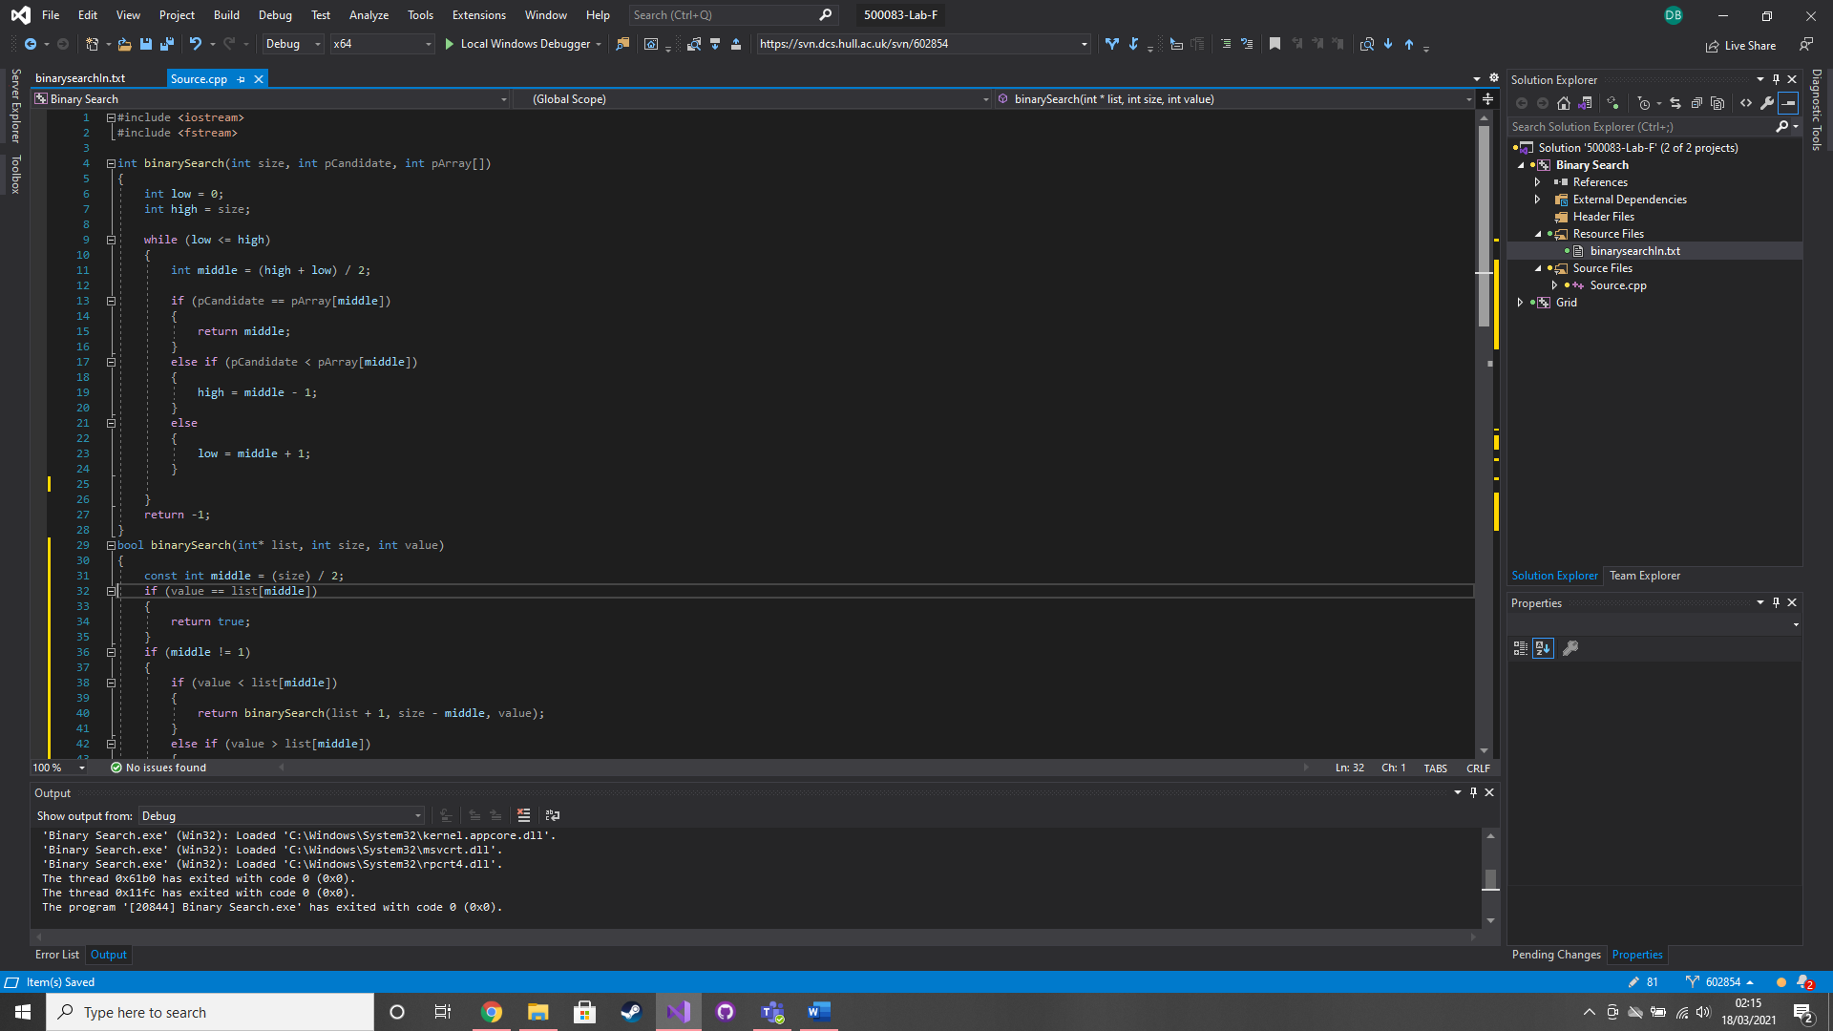

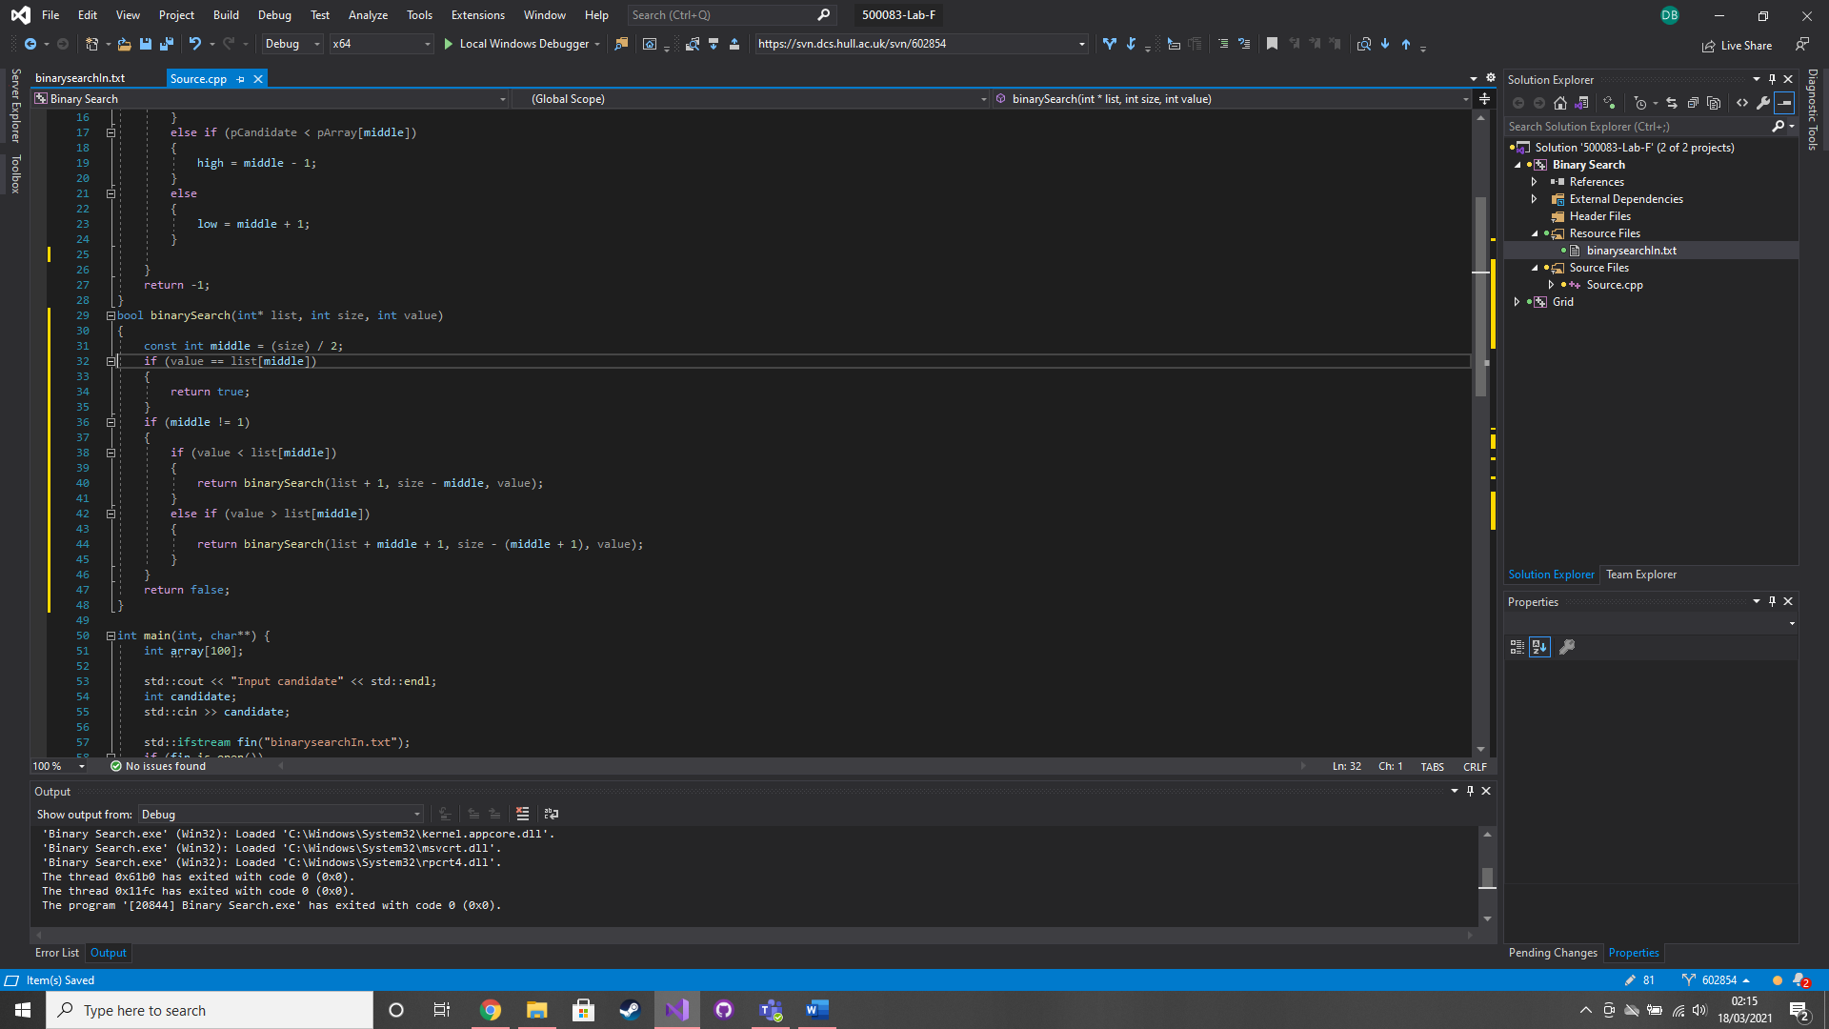

### Test data:

11

10

69

65

### Sample output:

Is in array

Isn’t in array

Is in array

Isn’t in array

### Reflection:

I definitely prefer the iterative approach it is a lot easier to read. However, in terms of design intent the recursive way seems better as it passes the array in using a pointer.

An array as a parameter implicitly gets converted to a pointer. So, int[] is the same as int*

### Metadata:

Binary Search

### Further information:

n/a

# Week 7 – Lab G

Date: 15/03/2021

### Q1. Parasoft

### Question:

Set up and test Parasoft

### Solution:

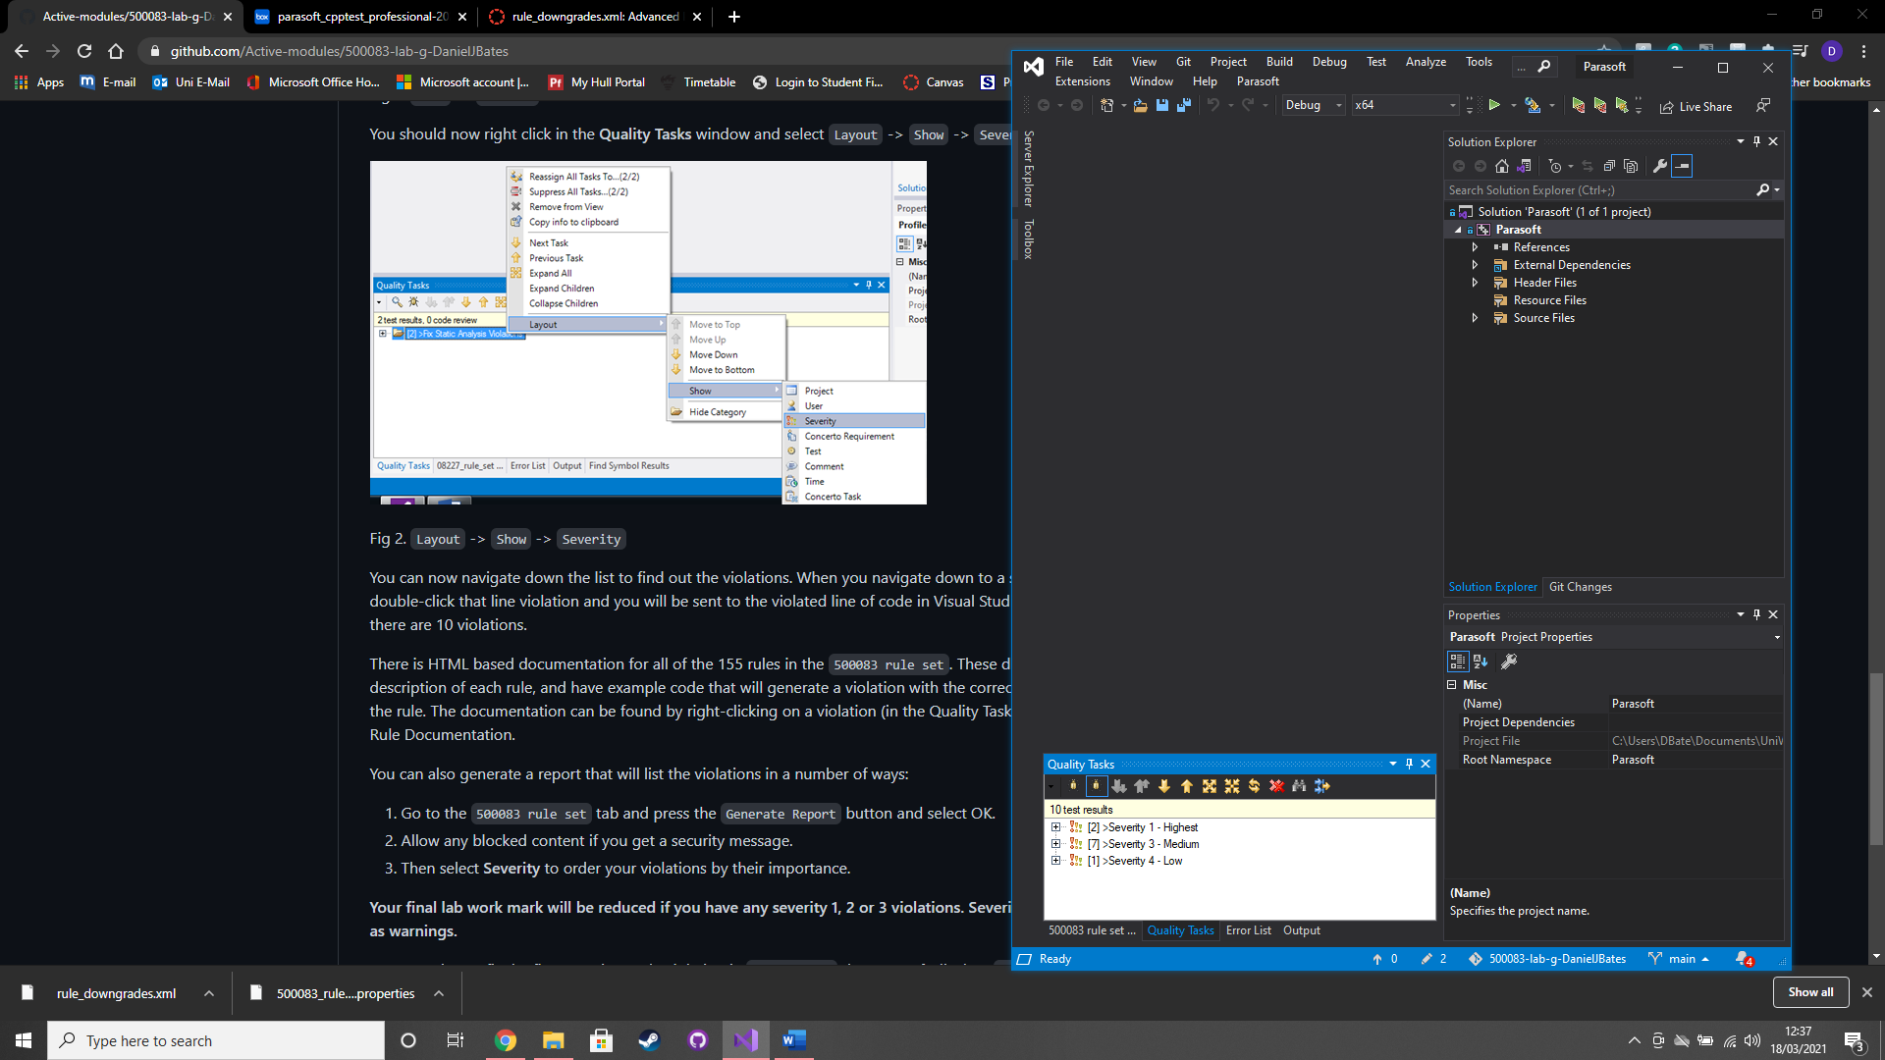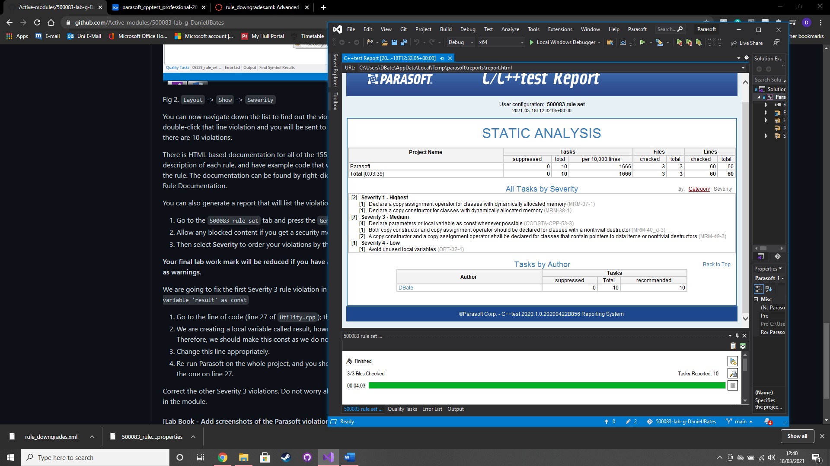

### Test data:

### Sample output:

### Reflection:

### Metadata:

### Further information:

# Week 8 – Lab H

Date: 22/03/2021

### Q1. PersonNode

### Question:

### Solution:

### Test data:

### Sample output:

### Reflection:

### Metadata:

### Further information:

### Q2. AddressBookSLL

### Question:

### Solution:

### Test data:

### Sample output:

### Reflection:

### Metadata:

### Further information:

### Q3. Find, Delete, Output

### Question:

### Solution:

### Test data:

### Sample output:

### Reflection:

### Metadata:

### Further information:

# Week 9 – Lab I

Date: 29/03/2021

### Q1.

### Question:

### Solution:

### Test data:

### Sample output:

### Reflection:

### Metadata:

### Further information: